Return to the Workplace Orientation Template
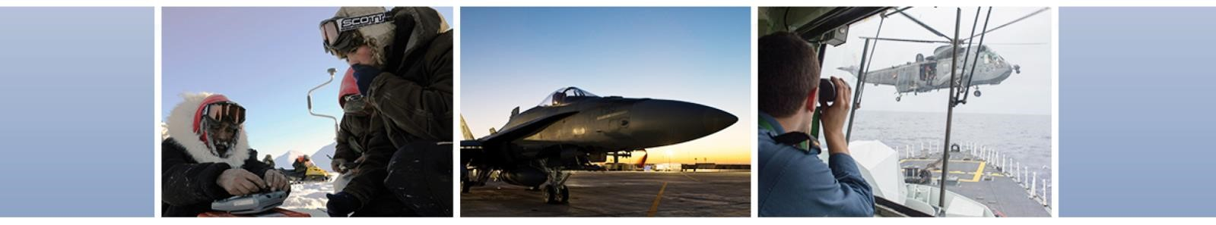
July 2020
Welcome back to your workplace!

Things have changed quite a bit since we entered Business Continuity Plan (BCP) posture on March 13. You may have seen some of the changes when you walked into the building to your workplace today, including directional signs, one way traffic flows and staircases, and physical distancing reminders. This orientation will provide you with some key information so you can get settled back in to a new normal at the workplace as we transition out of BCP to Business Resumption Plan (BRP) activities. If you have any questions that are not answered in this document please see your supervisor or [add appropriate OPI] or visit the Defence Team’s Resuming Work web page for more information. More specific operational information will come from [add appropriate OPI] separately.

Our priority remains your health and safety. Our [add appropriate OPI] have been working hard to ensure your return is smooth by assessing and readying the physical workplace to conform to the BRP and physical distancing requirements, and establishing individual team priorities so you can hit the ground running.

This orientation contains important information for you. Your [add appropriate OPI] will go through this with you and we are here to answer any questions or concerns.

What has changed?
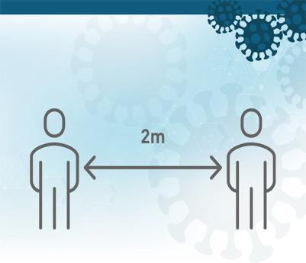

Our workspaces and facilities have changed. You may have noticed some changes when you came in today such as directional arrows on the floor to ensure pedestrian traffic flows in one direction, one-way staircases, some building occupants wearing masks, limited occupancy on elevators, less seating in common eating areas, and some collaborative spaces marked as not available. All these changes are to promote physical distancing.

The following Public Health Measures (PHM) as well as the use of non-medical masks are integral to a safe return to the workplace.

- Wash hands with soap and water for at least 20 seconds;
- Use alcohol-based hand sanitizer;
- Avoid touching eyes, nose, or mouth with unwashed hands;
- Avoid close contact with people who are sick;
- Cough or sneeze into a tissue or sleeve and not in hands;
- Respect physical distancing (2m/6’);

You may also see the following measures to promote physical distancing and keep you safe:

- Certain doors into Secure Zones designated as In or Out and marked with signage.

- During a fire alarm or evacuation you can use whatever door is closest and follow usual evacuation protocols. We will ensure that enough trained staff are available to help in an emergency situation. Given that some of your colleagues are working from home, you may be asked to volunteer to help in this regard. More news will follow on this topic.

- Certain hallways may be one-directional or off limits and marked with red X’s to allow for more cubicles to be occupied and allow for 2M distance to others.

We have marked the workspace temporarily with directional arrows and signage to assist us. Your [add appropriate OPI] will walk you around and explain the signage for clarity.
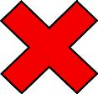

- Confined spaces such as printer rooms or washrooms may not be a one-way area. Entering and exiting these spaces will require communication and respect of personal space between colleagues. Please wait outside the room until it is available to use and communicate your movements to your colleagues who are using the space. We will place cleaning products in printer areas for disinfecting. Please follow the directions for sanitizing surfaces, especially electronic devices that may be more susceptible to damage.

- Collaborative spaces will be limited and may be adjusted to allow for 2M distance.

- Any visitor chairs in cubicles should be removed at this time. They can be labeled and stored to promote physical distancing.

- Conference rooms will have less seating and some chairs will be removed to promote physical distancing. Rooms must remain with limited seating until we are informed otherwise. Self-regulation will be required and group meeting sizes will need to be minimized.

- A temporary “no assigned seats” posture and/or a staggered seating arrangement for cubicle occupancy can allow for 2M physical distancing. We recognize that this can be disruptive and we appreciate your cooperation. If you have concerns about ergonomic considerations and arrangements, please speak to your supervisor.

- As long as the work area and the assignment of seating ensures a 2M distance, the wearing of a mask at your cubicle while you are working is not necessary. The non-medical masks are provided to you in the event you cannot ensure a 2M distance from someone while working or walking around.
- Every member of staff is being provided with non-medical masks for use when 2M distancing cannot be respected. Contact your manager or chain of command in order to obtain your non-medical masks. You are encouraged to wear these masks when appropriate. For details, visit the Government of Canada’s About non-medical masks and face coverings web page.
- The Department of National Defence (DND) has designed training on COVID-19 which is mandatory for all staff and was created by Canadian Forces Health Services Group. The course title is: COVID-19 Awareness / Sensibilisation à COVID-19 MITE 122255. It is available on the DLN:
  - DWAN/DVPNI: http://dln-rad.mil.ca
  - Home Internet: https://dln-rad.forces.gc.ca/login

ILLNESS REPORTING - VERY IMPORTANT

It is critical that you do not report to work if you are sick or feeling unwell. Report your absence to your supervisor immediately. If you feel ill at work please advise your supervisor immediately and leave the workplace. You should not use any DND shuttles or take public transit. It will be important to stay in touch with your supervisor to advise if you have any COVID-19 symptoms so appropriate steps can be taken for contact tracing. Always follow the advice of the local public health authorities.

If you are/were in the workplace and it is confirmed by a healthcare provide that you are/were infected with COVID-19, under the Canada Labour Code, this constitutes a workplace hazard. Therefore, you have a duty to report this hazard to management. This information helps the employer determine the time period when you were in the workplace, and if other members of staff may have been exposed.

Building services

Since March, extra cleaning protocols have been put in place in facilities such as extra cleaning of frequent touch points like door knobs, elevator touch points and bathrooms. Enhanced cleans will be ordered by Management if deemed appropriate (for example, in the case of a potential COVID-19 contact.)

Keeping your desk free from clutter and paper will facilitate cleaning so you are encouraged to keep a clean desk.

Food services [optional]

We are still gathering information on the services that will be available onsite. It is expected that food and other services will open again in a phased approach. We will inform you once we have details to share. It is expected that these services will also be following the recommended public health directions for physical distancing, please follow all instructions posted. Use of the kitchen areas, fridges and microwaves will require physical distancing.

New tools, supplies and arrangements

In [add your organization] we have provided you with non-medical masks for your personal use.

Disinfecting stations with supplies like disinfecting spray, paper towels and disinfecting wipes are located in common areas and in some conference rooms. You are encouraged to use these after you use the area(s). These stations are clearly marked and will be continually stocked.
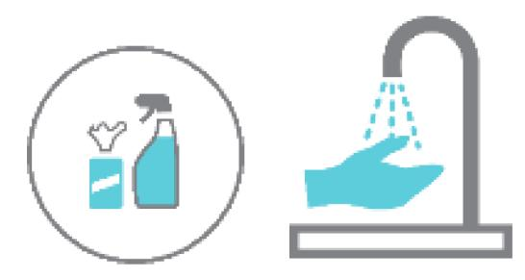

Defence O365

DND recently rolled-out the use of Defence O365, including MS Teams. Please familiarize yourself with this technology and use it to communicate and collaborate with your teammates and colleagues. This tool can be used for instant messaging, video conferencing and document collaboration. Training is available, please take the time to learn about and become familiar with this new tool.

Looking forward

Your collaboration, communication, participation and patience will be essential as we get used to this “new normal” and new way to operate to ensure everyone’s health and safety. The KEY will be for us to learn… listen… observe… adjust.

Additional information

The following links are provided for your information:

- Defence Team – COVID-19 web page
https://www.canada.ca/en/department-national-defence/campaigns/covid-19.html
- Employee Assistance Program (EAP)
http://hrciv-rhciv.mil.ca/en/e-employee-assistance-program.page
- HR Go
http://hrciv-rhciv.mil.ca/en/s-digital-hr-go-rh.page
- DM/CDS Directive – Public Health Measures and Personal Protection (May 1, 2020)
https://www.canada.ca/en/department-national-defence/corporate/policies-standards/dm-cds-joint-directive.html
- Joint CDS/DM Directive for the Resumption of Activities (May 22, 2020)
https://www.canada.ca/en/department-national-defence/corporate/policies-standards/joint-cds-dm-directive-for-the-resumption-of-activities.html
- Public Health Agency of Canada (PHAC)
https://www.canada.ca/en/public-health.html

