Bed-related Entrapment and Fall Report Form

Historically, incident reports for patient entrapments do not provide authorities with sufficient detail to allow a full assessment of the incident and a determination of whether any standards or guidelines that the bed conforms to are adequate.

This is where the reporter can play a very important role. For any entrapment incidents, please use this form to record important information, whether these incidents result in injuries or not. Please provide a copy of this form to the Health Products and Food Branch Inspectorate:

HEALTH CANADA
250 Lanark Avenue, 3rd Floor
Address Locator: 2003D
Ottawa, Ontario K1A 0K9
Tel: The Inspectorate Hotline 1-800-267-9675
Fax: (613) 954-0941
email MDCU_UCIM@hc-sc.gc.ca

As well, a copy of the form may be provided to the manufacturer to allow them to use this information to investigate the incident and improve their bed designs where applicable.

The purpose of the form is to report Entrapment incidents. The form can also be used to record falls data, but unless the fall resulted from a failure of components of the bed (i.e. side rail latch), fall data need not be communicated to Health Canada. In this context, please ensure that at a minimum, the following section be completed

An entrapment is defined as a patient being caught, trapped or entangled in the spaces in or about the bed rail, mattress or hospital bed frame.

A bed-related fall is defined as a fall that occurs from bed when a patient is getting out of bed, into bed or when a patient accidentally falls from the bed to the floor.

Date of incident | / /  Day / Month / Year
Time of  incident | : (24 hour clock)

1. Facility __________________________

2. Unit __________________________


3. Room/Bed Number ____________________

4. Bed Barcode number

5. Bed Make __________________________

6. Bed Model __________________________

7. Patient Name __________________________ ________________________
Last Name First Name
and/or

Patient Identifier __________________________

(This information is optional but would help in further investigation by the authorities)

8. Patient Age (in years)

9. Mental Status at time of incidence

Alert & Mildly Severely Comatose/Vegetative Baseline
Oriented Confused Confused State Intellectual
Disability

10. Does patient have a seizure or movement disorder? Yes No

11. Gender Male Female

12. Height __________

13. Weight __________

14. Patient’s admitting diagnosis: __________________________________________________________________________________________________________________________________________________________________________________________________________________________________________________________________________________________________________________________________________

15. Date of admission / /

Day / Month / Year

16. Description of Incident, including events leading up to the incident: ____________________________________________________________________________________________________________________________________________________________________________________________________________________________________________________________________________________________________________________________________________________________________________________________________________

17. Type of incident | 18. Was the patient injured? | 19. What treatment was  provided?
Entrapment | Yes | None
Bed-related  fall | No | First Aid
 | If yes, describe condition: | Medical/Surgical  Intervention  Other

20. Was the incident reported? | 21. Would this incident have normally been reported? | 22. What was the patient’s level of mobility at time of incident?
Yes | Yes | Up ad lib
No | No | Ambulate with  Assistance
Ambulate with

walker

Wheelchair/

chair bound

 |  | Bed bound
 |  | Missing limbs

23. What was the patient’s communication ability at time of incident?

Verbal

Nonverbal only

Sign language

Foreign language

24. Accessories and Treatments in Use

Rail bumper wedges |  | Rail pads |  | Rail covers |  | Entrapment shields
“Stuffer pads” |  | Bed rail extenders |  | Bed rail inserts |  | Positioning  monitors
Bed exit alarm |  | Raised perimeter mattress |  | Positioning aid |  | Net enclosure
Nasal oxygen |  | IVs |  | Overbed  table
Other |  | Other |  | Other |  | Other

25. If an entrapment event occurred, indicate the location of entrapment by circling the appropriate Zone number.

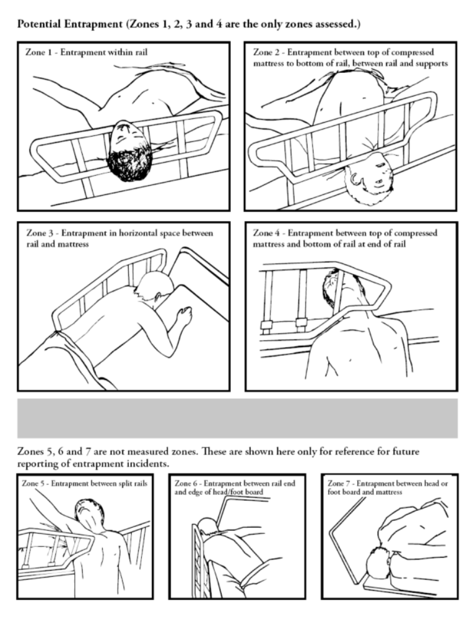

26. What body part was entrapped? Neck Head Chest Other

27. What was the size of the body Neck Head Chest Other:
part that was entrapped? diameter breadth depth
(width), (thickness)
ear to ear

28. Was patient in restraints? Yes No

If yes, indicate type. Check all that apply.

Vest/chest |  | Wrist soft--bilateral |  | Ankle soft--bilateral |  | Mitt--bilateral
Pelvic/crotch |  | Wrist soft--one |  | Ankle soft--one side |  | Mitt--one
Combination chest/pelvic |  | Wrist leather--bilateral |  | Ankle leather--bilateral |  | Other
Waist/Belt/  roll belt |  | Wrist leather--one |  | Ankle leather--one side

29. Circle the appropriate diagram on the next page that best indicates the Rail Configuration on the bed involved in the entrapment.

Also show where the entrapment occurred (drawing complete body is best).

Other, describe

Measure and report the size of the gap where the entrapment took place:

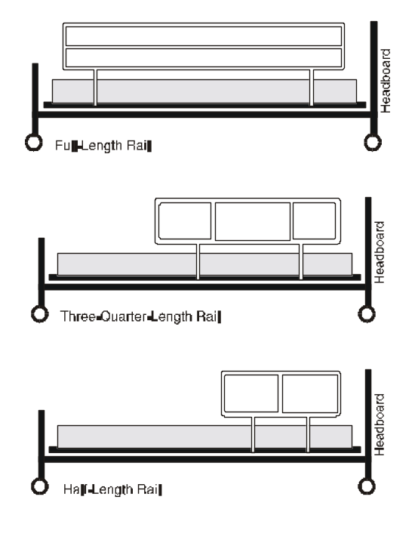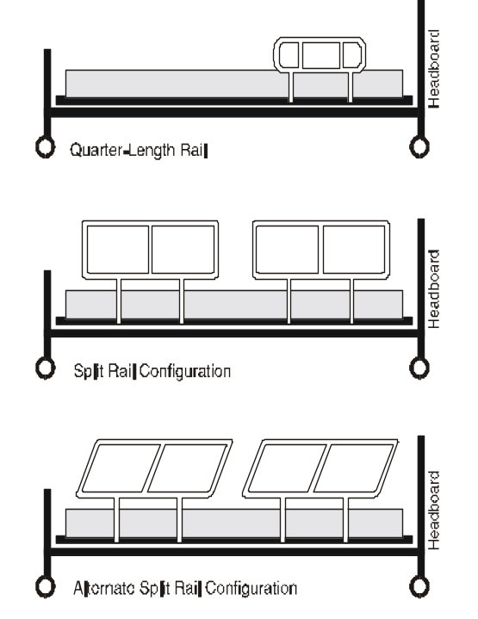

30. Were bed rails:
All up | All down | 1 up  (Patient’s Left ,  Patient’s Right ) | Top half up  (Patient’s Left ,  Patient’s Right ) | Bottom half up (Patient’s Left ,  Patient’s Right )

 | Yes | No | Don’t Know
31. Were the bed rails those recommended by the manufacturer?

32. What was the upper bed deck articulation?

 | Flat |  | 46 to 89 degrees
 | 15 to 30 degrees |  | 90 degrees
 | 31 to 45 degrees

33. What was the lower deck articulation?

 | Flat |  | 46 to 89 degrees
 | 15 to 30 degrees |  | 90 degrees
 | 31 to 45 degrees

34. Type of Mattress

 | Standard (Foam) |  | Other, specify
 | Water-filled
 | Air-filled

35. Mattress size:
As stated on label or other documentation:

length width depth

As measured with measuring tape, no compression:

length width depth

36. Mattress age (or production date)

37. Mattress condition (i.e. soft, firm, worn, torn, etc)

 | Yes | No | Don’t Know
38. Was the mattress one of those recommended by the manufacturer?

39. Was this bed assessed as per the Health Canada guidance on beds and if so what was the result?

 | Yes | No | Don’t Know
40. Did this bed meet the IEC 60601-2-52 international standard for medical beds?

41. Reporter contact information:

Name:

Facility Name:

Facility Address:

Phone number:

Fax Number:

Email:

