Risk Assessment Summary:
Performed by: Click here to enter text.
Date Completed: Click here to enter a date.
Human ☐RG1 ☐RG2 ☐RG3 ☐RG4
Animal ☐RG1 ☐RG2 ☐RG3 ☐RG4
This risk assessment tool is intended for stakeholders, already familiar with the concepts of biosafety and risk assessment, to use to classify the agents in their inventories. Any questions about how to use this tool can be directed to the Biosafety Risk Assessment Group at PHAC.pathogens-pathogenes.ASPC@canada.ca.

Pathogen Risk Assessment
Pathogen Name:

Taxonomy:
Agent Type (e.g., Bacteria, Virus):
Family:
Subfamily:
Genus:
Species:
Sub-Species:
Other (e.g., clonal isolate, serotype, serovar, biovar):

Pathogen Oversight

Regulatory Authorities
The outcome of this risk assessment will be a risk group classification for humans and animals that will determine the requirements for working with the agent being assessed under the Human Pathogens and Toxins Act and Health of Animals Act; however, there may be other requirements associated with the agent being assessed. This section will assist you in identifying what additional oversight may exist and determining who to contact prior to commencing work.

During your literature search, determine whether the agent has the ability to infect humans, terrestrial animals, aquatic animals, plants or bees. Even opportunistic infections should be noted, regardless of the risk group outcome of your assessment. Identify whether the agent is subject to official control. This will help you identify who you will need to contact in order to work with the agent in the laboratory.

  - Is the pathogen a
☐strain, clonal isolate, or recombinant variant of a pathogen with a known risk group (RG)?
☐human pathogen?*
☐terrestrial animal pathogen?*
☐non-indigenous animal pathogen?**
Notes:
☐OIE listed disease?**
Notes:
☐aquatic animal pathogen?**
☐plant pathogen?**
☐bee pathogen?**

  - Is the pathogen subject to official control?
☐National Notifiable Disease
☐Domestic Substances List
☐Reportable Disease
☐Immediately Notifiable Disease
☐Annually Notifiable Disease
☐Plant Protection Regulations
☐Quarantine Act
☐Provincial Notifiable Disease
Other (list):
* Human and terrestrial animal pathogens may be regulated by the Public Health Agency of Canada.
** Terrestrial animal pathogens that are non-indigenous to Canada (cause foreign animal and emerging animal diseases), aquatic animal pathogens, plant pathogens, and bee pathogens may be regulated by the Canadian Food Inspection Agency.

Biosecurity Oversight
Biosecurity refers to security measures designed to prevent the loss, theft, misuse, diversion, or intentional release of pathogens, toxins, and other related assets (e.g., personnel, equipment, non-infectious material, and animals).
- Identify whether the agent appears on any of the lists of agents of potential concern for biosecurity. Agents on these lists may be subject to additional security requirements.
- Identify whether there are any biosecurity considerations that should be noted in the risk assessment. Provide a brief summary, supported by references where possible, as to the potential biosecurity concerns related to this agent. Any biosecurity concerns should be fully elaborated in your Biosecurity Risk Assessment and Biosecurity Plan. The requirements related to biosecurity are fully elaborated in the Canadian Biosafety Standard.
☐ Australia Group Common Controls List
☐ Select Agents and Toxins List
☐ Security Sensitive Biological Agent
☐ This pathogen has no known biosecurity concerns. If so, please proceed to section 2.

Notes:
Briefly describe biosecurity considerations that could impact the risk assessment. The full details should be elaborated in your Biosecurity Plan.

Pathogen Description
Provide background information that could be relevant to the interpretation of the risk assessment or overall risk. Provide references to support your comments. Some of the types of information that may be applicable to the pathogen risk assessment are listed below.
- Example 1, when assessing a recombinant virus, the genome structure of the native virus and modifications should be described in sufficient detail to determine how the modifications will impact the different factors being assessed (e.g., pathogenicity).
- Example 2, when assessing bacteria or fungi, the ability to product toxins may directly impact pathogenicity.
- Example 3, when assessing fungi with complex taxonomy or numerous changes to taxonomy, current and historical nomenclature should be described.
Reconstructed, engineered, or modified pathogens should be assessed throughout the risk assessment by comparing the newly created pathogen to the wild type or a previously assessed variant, linking the various modifications to anticipated effects on the different risk factors (e.g., pathogenicity, communicability).
General Information
      - Taxonomy
- Historical background
- Size
- Shape
- Structure
- Genome structure/information
- Ideal growth conditions
- Modifications (e.g., CRISPR gene drives)
- Temperature tolerance
Bacteria
- Motility
- Sporulation
- Toxin production
- Oxygen requirements
- Gram staining, AF staining
- Enzymatic activity
Viruses
- RNA/DNA virus
- Single/Double stranded
- Other classifications
Other (e.g., Fungi, Protozoa)
- Life cycle
- Reproduction
- Morphology
- Growth and physiology
- Toxin production

Pathogenicity (Individual Risk)

Assessment of Human Pathogenicity Indicators
Assess the indicator questions and use these to rate the likelihood of serious disease. Use the rationale section under each question to substantiate your analysis with a description and corresponding references.

Outline uncertainty and assumptions within the rationale for each indicator. The greater the assumptions/uncertainty, the more frequently the risk assessment should be reviewed.

1) If exposed, what is the likelihood that infection would result, with or without overt signs of disease?
☐ None ☐ Low ☐ Moderate ☐ High ☐ Unknown

Rationale:

2) If exposure led to disease, what is the likelihood that there would be acute signs of disease?
☐ None ☐ Exclusively in susceptible populations ☐ Low ☐Moderate ☐ High ☐ Unknown

Rationale:

3) If exposure led to disease, what is the likelihood that there would be serious sequelae or mortality?
☐ None ☐ Exclusively in susceptible populations ☐ Low ☐Moderate ☐ High ☐ Unknown

Rationale:

4) Are certain populations (e.g., pregnant, elderly, immunocompromised) at an increased risk of infection or disease?
☐ Yes ☐ No ☐ Unknown

Rationale:

Rate the likelihood of serious disease considering the Human Pathogenicity Indicators above.
☐ None, the agent is not a human pathogen;
☐ Low, the agent is an extremely rare opportunistic pathogen. Serious disease may occur in severely ill or immunocompromised;
☐ Moderate, the agent is able to cause serious disease but is unlikely to do so; or
☐ High, the agent is likely to cause serious disease.

Assessment of Natural Animal Host(s) Pathogenicity Indicators
Assess the indicator questions and use these to rate the likelihood of serious disease in the natural animal host. Natural animal hosts are those where infection and/or disease in the animal would occur in a natural environment, and includes wild animal species (e.g., wild rodents, ruminants, etc.). Information obtained under experimental conditions designed to reproduce natural exposure may be of use. Other information obtained from experimentally infected animals should be considered as surrogate data only. Use the rationale section under each question to substantiate your analysis with a description and corresponding references.

Outline uncertainty and assumptions within the rationale for each indicator. The greater the assumptions/uncertainty, the more frequently the risk assessment should be reviewed.

1) If exposed, what is the likelihood that infection would result, with or without overt signs of disease?
☐ None ☐ Low ☐ Moderate ☐ High ☐ Unknown

Rationale:

2) If exposure led to disease, what is the likelihood that there would be acute signs of disease?
☐ None ☐ Exclusively in susceptible populations ☐ Low ☐Moderate ☐ High ☐ Unknown

Rationale:

3) If exposure led to disease, what is the likelihood that there would be serious sequelae or mortality?
☐ None ☐ Exclusively in susceptible populations ☐ Low ☐Moderate ☐ High ☐ Unknown

Rationale:

4) Are certain populations at an increased risk of infection or disease?
☐ Yes ☐ No ☐ Unknown

Rationale:

Rate the likelihood of serious disease considering the Natural Animal Host Pathogenicity Indicators above.
☐ None, the agent is not an animal pathogen;
☐ Low, the agent is an extremely rare opportunistic pathogen. Serious disease ;may occur in severely ill or immunocompromised;
☐ Moderate, the agent is able to cause serious disease but is unlikely to do so; or
☐ High, the agent is likely to cause serious disease.

Pre- and Post-Exposure Measures (Human Community Risk)

Assessment Human Pre- and Post-Exposure Measures Indicators
Assess the indicator questions and use these to rate the level of protection from infection and/or the development of disease. Use the Rationale section under each question to substantiate your analysis with a description and corresponding references.

1) Are pre-exposure measures available to prevent infection or disease (e.g., vaccines, pre-exposure prophylaxis)?
☐ Not available
☐ Limited availability
☐ Readily available for use on-demand
☐ Widely available and in use in the community
☐ Unknown

Rationale:

2) Are these pre-exposure measures effective at preventing infection or disease?
☐ Not applicable, pre-exposure measures are not available
☐ Not effective, minimal protection
☐ Moderately effective, partial protection
☐ Highly effective*, almost complete protection
☐ Unknown

Rationale:

3) Are post-exposure measures available to treat infection or prevent disease (e.g., post-exposure prophylaxis, antibiotics, antifungals, antivirals)?
☐ Not available
☐ Limited availability
☐ Readily available for use on-demand
☐ Widely available and in use in the community
☐ Unknown

Rationale:

4) Are these post-exposure measures effective at treating infection or preventing disease?
☐ Not applicable, post-exposure measures are not available
☐ Not effective
☐ Moderately effective
☐ Very effective
☐ Unknown

Rationale:

5) Are there sub-populations in which the use of or access to pre-exposure measures is less than the general population?
☐ Yes ☐ No ☐ Unknown

Rationale:

Rate the level of protection from infection and/or the development of disease considering the Pre- and Post-Exposure Measures Indicators above.
☐ None, if exposed, the community would not be protected;
☐ Moderate to low, if exposed, the community would be somewhat protected;
☐ Very high*, if exposed, the community would be generally protected; or
☐ Unknown.
*Note. It is rare for the level of protection in the community to be very high. For example, community protection against Measles virus is very high because there is a highly effective vaccine and the majority of Canadians are vaccinated.

Communicability (Human and Animal Community Risk)

Assessment of Human Communicability Indicators
Assess the indicator questions and use these to rate the likelihood of human-to-human transmission by direct or indirect contact. Use the “Rationale” section under each question to substantiate your analysis with a description and corresponding references. Note that route of infection (e.g., ingestion, inhalation) only partially addresses the likelihood of human-to-human transmission. For example, an environmental fungus may be likely to produce infection through inhalation of environmental spore, but not transmit from person-to-person, directly or indirectly. Other modes of transmission (e.g., vertical) can be noted but will not impact the final RG classification.
1) What is the likelihood of infection or disease arising from ingestion?
☐ None ☐ Low, unlikely ☐ Moderate, possible ☐ High, preferred route ☐ Unknown

Rationale:

2) What is the likelihood of infection or disease arising from injection (e.g., accidental or intentional inoculation, penetrating wounds)?
☐ None ☐ Low, unlikely ☐ Moderate, possible ☐ High, preferred route ☐ Unknown

Rationale:

3) What is the likelihood of infection or disease arising from arthropod vectors (e.g., through bites of infected arthropod species, such as mosquitoes and ticks)?
☐ None ☐ Low, unlikely ☐ Moderate, possible ☐ High, preferred route ☐ Unknown

Rationale:

4) What is the likelihood of infection or disease arising from contact of the agent with intact skin?
☐ None ☐ Low, unlikely ☐ Moderate, possible ☐ High, preferred route ☐ Unknown

Rationale:

5) What is the likelihood of infection or disease arising from contact of the agent with mucous membranes or damaged skin?
☐ None ☐ Low, unlikely ☐ Moderate, possible ☐ High, preferred route ☐ Unknown

Rationale:

6) What is the likelihood of infection or disease arising from inhalation of the agent (e.g., large or small droplet aerosols, spores)?
☐ None ☐ Low, unlikely ☐ Moderate, possible ☐ High, preferred route ☐ Unknown

Rationale:

7) What is the likelihood of disease arising from exposure to affected animals, through either direct or indirect contact?
☐ Not zoonotic ☐ Low, unlikely ☐ Moderate, possible ☐ High, common mode of transmission

Rationale:

Based on the analysis of the Human Communicability Indicators above, rate the likelihood of human-to-human transmission by the following modes of transmission (more than one may be applicable).
Direct Contact (Casual)
☐ None ☐ Unlikely ☐ Possible ☐ Likely ☐ Unknown
Direct Contact (Intimate)
☐ None ☐ Unlikely ☐ Possible ☐ Likely ☐ Unknown
Indirect Contact (Fomites)
☐ None ☐ Unlikely ☐ Possible ☐ Likely ☐ Unknown
Indirect Contact (Vectors)
☐ None ☐ Unlikely ☐ Possible ☐ Likely ☐ Unknown

Assessment of Animal Communicability Indicators
Assess the indicator questions and use these to rate the likelihood of animal-to-animal transmission by direct or indirect contact. Use the “Rationale” section under each question to substantiate your analysis with a description and corresponding references. Note that route of infection (e.g., ingestion, inhalation) only partially addresses the likelihood of animal-to-animal transmission. For example, an environmental fungus may be likely to produce infection through inhalation of environmental spore, but not transmit from animal-to-animal, directly or indirectly. Other modes of transmission (e.g., vertical) can be noted but will not impact the final RG classification.
1) What is the likelihood of infection or disease arising from ingestion?
☐ None ☐ Low, unlikely ☐ Moderate, possible ☐ High, preferred route ☐ Unknown

Rationale:

2) What is the likelihood of infection or disease arising from injection (e.g., accidental or intentional inoculation, penetrating wounds)?
☐ None ☐ Low, unlikely ☐ Moderate, possible ☐ High, preferred route ☐ Unknown

Rationale:

3) What is the likelihood of infection or disease arising from arthropod vectors (e.g., through bites of infected arthropod species, such as mosquitoes and ticks)?
☐ None ☐ Low, unlikely ☐ Moderate, possible ☐ High, preferred route ☐ Unknown

Rationale:

4) What is the likelihood of infection or disease arising from contact of the agent with intact skin?
☐ None ☐ Low, unlikely ☐ Moderate, possible ☐ High, preferred route ☐ Unknown

Rationale:

5) What is the likelihood of infection or disease arising from contact of the agent with mucous membranes or damaged skin?
☐ None ☐ Low, unlikely ☐ Moderate, possible ☐ High, preferred route ☐ Unknown

Rationale:

6) What is the likelihood of infection or disease arising from airborne transmission (e.g., large or small droplet aerosols, spores)?
☐ None ☐ Low, unlikely ☐ Moderate, possible ☐ High, preferred route ☐ Unknown

Rationale:

7) What is the likelihood of disease arising from exposure to affected humans, through either direct or indirect contact?
☐ Not zoonotic ☐ Low, unlikely ☐ Moderate, possible ☐ High, common mode of transmission

Rationale:

Based on the analysis of the Animal Communicability Indicators above, rate the likelihood of animal-to-animal transmission by the following modes of transmission (more than one may be applicable).
Direct Contact (Casual)
☐ None ☐ Unlikely ☐ Possible ☐ Likely ☐ Unknown
Direct Contact (Intimate)
☐ None ☐ Unlikely ☐ Possible ☐ Likely ☐ Unknown
Indirect Contact (Fomites)
☐ None ☐ Unlikely ☐ Possible ☐ Likely ☐ Unknown
Indirect Contact (Vectors)
☐ None ☐ Unlikely ☐ Possible ☐ Likely ☐ Unknown

Assessment of Public Health and Economic Impact of New and/or Emerging Human Pathogens (Human Community Risk)
Complete this section only for new or emerging human pathogens. New or emerging pathogens, including engineered or reconstructed pathogens, may pose unique risks to the public. Economic impact refers to the costs associated with things like treating disease, hospitalization and long term care, and lost wages due to missed work. Public health impact refers to the ability of a pathogen to infect, cause disease, transmit among, and produce serious disease or death in people. Use the Rationale section under each question to substantiate your analysis with a description and corresponding references. If you identify a new or emerging pathogen, please contact the Public Health Agency of Canada and, for emerging animal pathogens, the Canadian Food Inspection Agency to validate your risk assessment.

1) Is the agent a new or emerging pathogen? If yes, complete the remainder of this section. If no, proceed to Section 7 (Host Range, Natural Distribution, and Economic Impact).
☐ No (Proceed to Section 7) ☐ Yes (Provide detailed rational for questions 2 and 3 below)

Rationale:

2) Would there be a significant impact on the economy if the pathogen were released from the laboratory (e.g., costs related to hospitalization, drugs, vaccination, and/or lost work as a result of illness)?
☐ No, the anticipated economic impact would not be very high
☐ Yes, very high economic impact would be anticipated if the pathogen were released from the laboratory

Rationale:

3) Would there be a significant impact on public health if the pathogen were released from the laboratory (e.g., significant number of cases, high health care burden)?
☐ No, the anticipated public health impact would not be very high
☐ Yes, very high public health impact would be anticipated if the pathogen were released from the laboratory

Rationale:

Based on the analysis of the New and/or Emerging Pathogen Human Pathogen Indicators above, what is the predicted impact of the release of the pathogen from a laboratory on public health or the economy:
☐ Low to moderate, release from the laboratory is unlikely to have a significant impact on public health and/or the economy; or
☐ Significant, release from the laboratory is likely to have a significant impact on public health and/or the economy.

Host Range, Natural Distribution, and Economic Impact (Animal Community Risk)

Assessment of Host Range, Natural Distribution, and Economic Impact Indicators for Natural Animal Hosts
Assess the indicator questions and use these to rate the economic impact of releasing the pathogen from the laboratory on the natural animal host population. Use the Rationale section under each question to substantiate your analysis with a description and corresponding references.
1) How broad is the range of natural animal hosts that are susceptible to disease (host range)? Common classes: Amphibia, Aves, Chondrichthyes, Mammalia, Osteichthyes, Reptilia, Arachnida, Insecta.
☐ Extremely limited, single species
☐ Limited, single order
☐ Broad, single class
☐ Very broad, multiple classes
☐ Unknown

Rationale:

2) Are the natural host species in Canada?
☐ Natural host species are not in Canada
☐ Natural host species are present in restricted regions in Canada
☐ Natural host species are present throughout Canada
☐ Unknown

Rationale:

3) What is the natural distribution of the agent in Canada?
☐ Endemic in Canada
☐ Found infrequently in Canada; rare imported cases or limited natural distribution
☐ Found in Canada, but regionally restricted
☐ Not present in Canada
☐ Unknown

Rationale:

4) Considering animals in their order of economic importance*, what is the combined economic value of the natural animal host(s)?

☐ None/Not Applicable ☐ Low Value ☐ Medium Value ☐ High Value ☐ Unknown

Rationale:

5) Considering animals in their order of economic importance*, what is the combined economic value of the other animal host(s), for example experimentally infected animals?
☐ None/Not Applicable ☐ Low Value ☐ Medium Value ☐ High Value ☐ Unknown

Rationale:

Based on the analysis of the Host range, Natural Distribution, and Economic Impact Indicators above, the economic impact of release on the natural animal host population is:
☐ None ☐ Minimal ☐ Moderate ☐ Significant ☐ Unknown

* The Canadian Food Inspection Agency (CFIA) has classified animals in terms of their economic value of the related industries to Canada as follows:
- Highest value livestock industries: bovine, equine, porcine, poultry, crustaceans, finfish (wild and farmed).
- Medium value livestock industries: small ruminants (sheep and goats), bees, molluscs, other farmed ruminants (cervids, bison).
- Lowest value livestock industries and non-livestock animals: lagomorphs (rabbits), companion animals (dogs, cats, etc), reptiles, amphibians, rodents, non-human primates.

Risk Group Decisions
The risk group reflects the risk posed to the human (human risk group) and animal (animal risk group) populations. If the human and animal risk group values differ, the higher value dictates the level of containment required to work with the agent. In almost all cases, the risk group value and containment level values are the same (i.e., a risk group 3 agent will be handled in a containment level 3 lab, as described in the Canadian Biosafety Standard). In rare cases, the Public Health Agency of Canada will issue Biosafety Directives that outline specific derogations of containment for certain pathogens and/or activities (http://www.phac-aspc.gc.ca/lab-bio/res/advi-avis/index-eng.php).

Human Risk Group Decision
Use the decision tree to determine the risk group (RG) based on your overall rating of each of the human risk factor indicators.
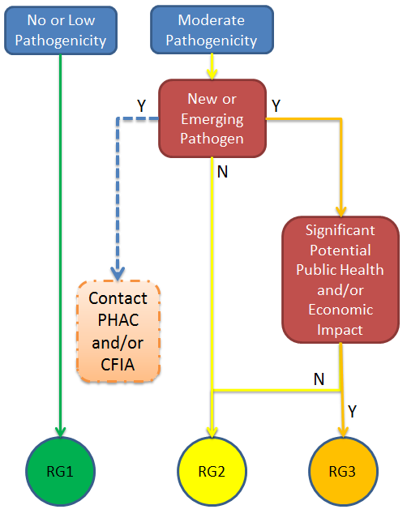
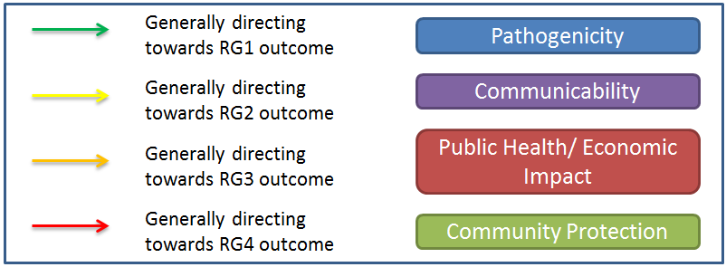
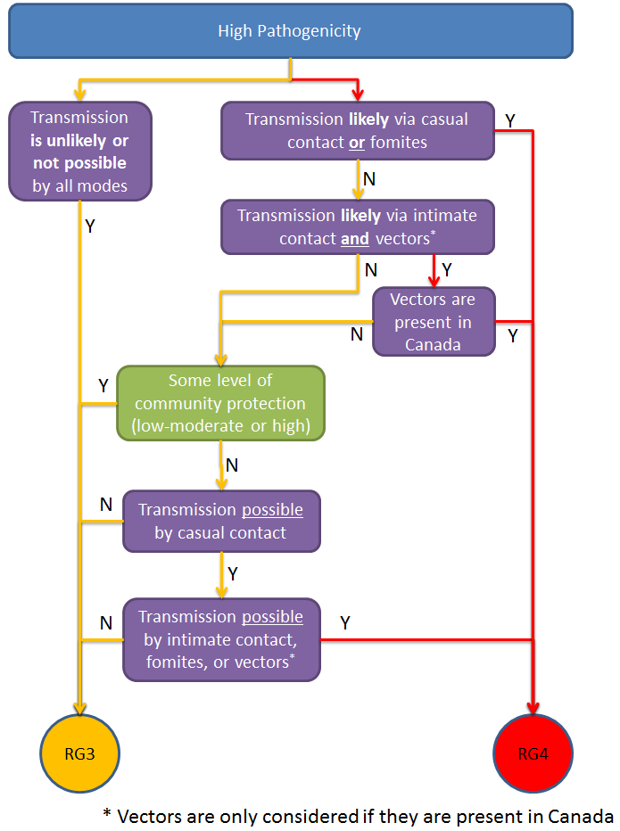
Human Risk Group: ☐ RG1 ☐ RG2 ☐ RG3 ☐ RG4

Animal Risk Group Decision
Use the decision tree to determine the risk group based on your overall rating of each of the animal risk factor indicators.

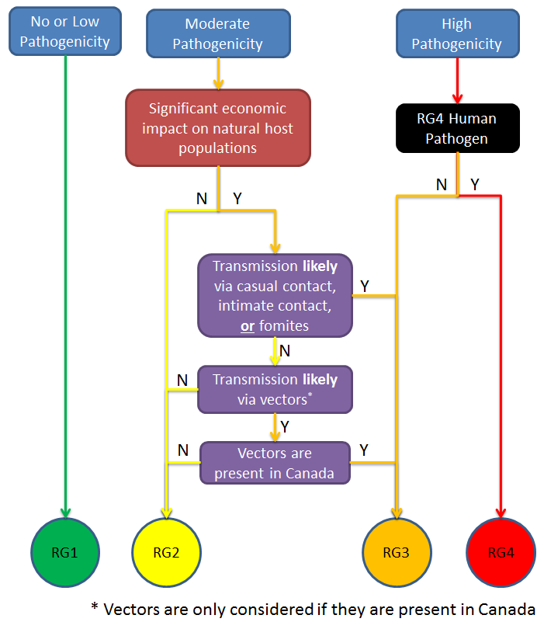

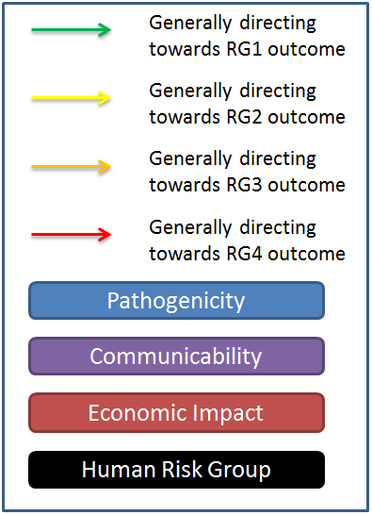

Animal Risk Group: ☐ RG1 ☐ RG2 ☐ RG3 ☐ RG4

References
All information provided in the risk assessment should be cited fully, using the highest quality data available.
- High quality data means it was sufficient for a thorough analysis of all elements of the risk assessment. High quality data sources include information from clinical trials and standardized studies.
- Medium quality data means it was sufficient for a thorough analysis of some elements of the risk assessment but that there were some data gaps and minor assumptions were made. Medium quality data sources include peer-reviewed publish literature and edited literature.
- Low quality data means it was insufficient for a thorough risk assessment and that there were major data gaps and major assumptions were made. Low quality data sources include expert opinion, independent communications, and uncited websites.

