
Candidate for Open Government
Public Service Commission Data Management Strategy: components and enablers
GCDOCS # 6561366
Data Services and Analysis Directorate

Contents

Contents i
Vision Statement 1
1. PSC Data Management Strategy - Introduction 1
2. Context 2
3. Business Case 4
4. Components of the PSC Data Management Strategy 4
4.1 Data Management 5
4.2 Data Infrastructure 8
4.3 Data Users - “Know, Understand, Present, Defend” 10
Appendix A - Governance Structure for Data Management Strategy 12
Appendix B - Chief Data Officer and Chief Information Officer: Roles and Responsibilities 14
Appendix C: Data Management Maturity Model (DMMM) 15
Appendix D: Acronyms 17

Vision Statement
The following vision for data management at the PSC has been endorsed by senior leadership:
The right data, the right way, in the right hands, at the right time.

1. PSC Data Management Strategy - Introduction
A data management strategy is the process of planning or creating strategies/plans for handling the data created, stored, managed and processed by an organization. It is a governance process that aims to create and implement a well-planned approach in managing an organization's data assets.
The PSC Data Management Strategy (the Strategy) has been developed based on both industry standards as well as customized elements which best meet PSC needs (e.g., data quality, infrastructure solutions, open government considerations).
The Strategy includes a number of interrelated elements including – Data Management Practices, Data Infrastructure, and Data Users, as well as a functional unit to support the execution of the Strategy.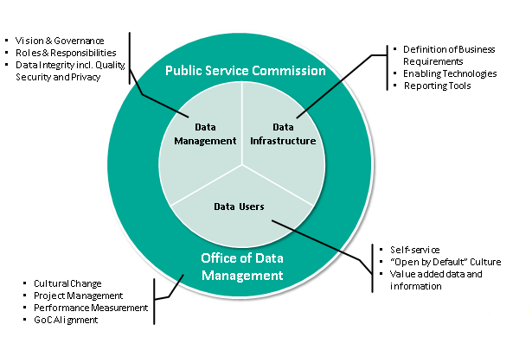
Figure 1: Elements of PSC’s Data Management Strategy
Sub-elements related to Data Infrastructure are definition of Business Requirements, Enabling Technologies and Reporting Tools.
Sub-elements related to Data Users are Self-service, "Open by Default" Culture and Value added data and information.
Sub-elements related to Data Management are Vision & Governance, Roles & Responsibilities and Data Integrity inluding Quality, Security and Privacy.
The sub-elements related to the Office of Data Management are the Cultural Change, Project Management, Performance Measurement and GOC Alignment.

2. Context
The mandate of the Public Service Commission (PSC) is to promote and safeguard a merit-based, representative and non-partisan public service. To support its mandate, the PSC collects large volumes of data at key points of the appointment process. These data can be found across several sources, including:
- Public Service Recruitment System (PSRS)
- Priority Information Management System (PIMS)
- Job-Based Analytical Information System (JAIS)
- Survey of Staffing (SOS)
- Employment Equity Databank (EEDB)
- Test Scoring and Results Reporting System (TSRR)
Historically, the PSC has collected and aggregated transactional data for reporting purposes; however, the staffing environment has evolved and so has our need for data. The Government of Canada (GoC) has a renewed focus on transparency, evidence-based policy and decision making, as well as measurable results for Canadians: PSC data plays an important role in supporting these areas.
A number of emerging trends in the Public Service have increased the need for data management within the PSC, including:

The new trends for people and processes are greater discretion for hiring managers (New Direction in Staffing), using data to improve programs and services (GoC Directive on Results) and renewal and diversity of the Public Service (Blueprint 2020).
The new trends for technology are government-wide focus on building infrastructure for data collaboration (GoC Framework for Addressing Canadian Policy Challenges with Data), connectivity and interoperability to facilitate "big data" analytics (GoC IT Strategic Plan 2017-2021) and protection of data privacy and security against cyber-attacks (GoC IT Strategic Plan 2017-2021).
The new trends for data are governance structures and mechanisms to manage information assets (GoC Policy on Information Management), use of high quality government data to inform decisions (GoC IT Strategic Plan 2017-2021) and make information resources more accessible to Canadians (GoC Directive on Open Governement).

An initial diagnostic of our data management practices suggests that we need to bolster our current processes, and build up our capacity to improve data competencies, tools and infrastructure going forward. Identified issues include:
- Lack of a data focused governance: We learned from the decommissioning of the PSC Business Intelligence and Enterprise Data Warehouse that data projects are better served by a data focused governance – as opposed to an IT driven governance, even if the project is enabled through technology.
- Working in data silos: To meet their business and reporting needs, sectors across the organization have developed their own data management practices and related processes. These practices have led to inconsistent approaches to data management and created risks to data quality.
- Working from live databases: Working from live databases poses a risk to the integrity of the data as well as to the performance of the systems. It also means the PSC is not in a position to consistently guarantee same data: given that the information is ever-changing creates the risk of producing different numbers for the same request.
- Emphasis on measurement rather than analytics: The PSC’s use of data has been primarily focused on the past, i.e., reporting on the transactions that have occurred, and relaying program data. Transactional data is typically used as an input for decision (rather than a driver) and provides little insight.
- Need for an infrastructure that supports data integration: The PSC has been working to update and improve its data infrastructure with the intention to centralize, standardize and integrate data to better support analytical and reporting functions across the organization. However, no solution has yet been identified and the modernization of our infrastructure is particularly critical as we plan to replace two important systems, namely PSRS and PIMS.

3. Business Case
The benefits stemming from the Strategy will not only address the current data challenges - it will position the organization for the future in supporting PSC’s core work:
- Report to Parliament on the performance of the staffing system and non-partisanship in the Public Service.
- Support evidence-based adjustments to policies.
- Facilitate improvements in program delivery.
- Strengthen the oversight function’s ability to identify risks early to initiate timely intervention.

As the organization’s analytical needs continue to grow in number and complexity due to evolving requirements, practices and expectations, the Strategy will also allow for:

- Stronger linkages between siloed data systems – reducing operating costs and increasing data value.
- Strengthened data management practices to track, protect and publish data.
- Enhanced capability to access and transform data.
- Improved capacity to respond to and explore questions of increasing complexity.

4. Components of the PSC Data Management Strategy
The core components of the Strategy – Data Management, Data Infrastructure and Data Users – have been established to support the achievement of the PSC data vision of having “the right data, the right way, in the right hands at the right time”. These core components have been based on industry standards and best practices, as well as on the specific needs of the PSC as identified through an initial diagnostic of the PSC data capacities. For each component of the Strategy, a number of Enablers and initiatives have been identified to achieve the vision. A separate plan will be developed to provide details on the actions and time lines.

4.1 Data Management
The Data Management component aims to establish an organizational standard for how we handle our data. This component will focus on four areas: governance, quality, security and privacy, and risks in order to accelerate the maturity of data management practices across the organization. These four areas were identified as key based on reviews of good data management practices in both the public and private sectors.
4.1.1 Data Governance: Data governance impacts all areas of data management and directly influences priorities as well as decision-making on the disposition of the Strategy. It is important to distinguish data governance from other organizational governance. Data governance is a partnership between business owners, data experts and technology stewards.
Recognizing the need for integrated governance that brings both operational and technical perspectives together, a new governance model has been established - see Appendix A: Governance Structure for Data Management Strategy. The Information Management/Information Technology Committee (IM/ITC) and the Integration Committee (IC) will meet jointly to oversee and provide guidance on the implementation of the Strategy as well as on other data related issues. They will ensure that changes to the design and implementation of business and systems solutions consider the longer needs for the PSC data assets.
Further, to provide organization-wide leadership for data and related issues, the PSC has appointed a Chief Data Officer (CDO). The CDO will be accountable for:
- Developing, executing and reporting on the implementation of the Strategy.
- Driving the cultural change needed to manage data as a corporate asset.
- Creating synergy across multiple functional areas, including the Information Management Senior Officer/Chief Information Officer. (See Appendix B for Roles and Responsibilities).
- The overall quality, interpretation and use of data in support of policy development, program improvement and reporting.

Strategy Enablers:
      - Establish the Data Management Governance through the creation of a joint IM/IT and Integration Committee
- Update the Terms of Reference for the IM/ITC, IC and other working groups such as the Data and Open Government Advisory Board.

      - Establish the Office of Data Management (ODM) to support the CDO and Champion for Open Government
- Socialize the concept and responsibilities of CDO across the organization.
- Provide support in the areas of data management best practices, awareness, learning, change management and communication.
- Establish performance measures to identify current data management maturity and track incremental improvements over time. (See Appendix C: Data Management Maturity Model).
- Coordinate and deliver on the Open Government Implementation Plan.

      - Adopt a robust project management approach to implementing the PSC Data Management Strategy
- Develop a project charter and action plan to execute the Strategy and report on progress to the joint IMITC/IC quarterly.
- Maintain timely communication on the vision and progress of the Strategy through various channels.

4.1.2 Data Quality: There are many definitions of data quality but data is generally considered high quality if it is "fit for its intended uses in operations, decision making and planning". Among others, accuracy, completeness, relevance, timeliness, accessibility, and interpretability are key elements of data quality.
Having high quality data available to support decision-making and reporting is critical to meeting the PSC mandate and it is the responsibility of all employees to support the promotion, the development and transmission of quality data.

Strategy Enablers:

      - Develop and implement a PSC Policy on Data Quality
- Research, consult and implement a PSC Policy on Data Quality.
- Monitor compliance to the PSC Policy on Data Quality.
- Institute Building Permits to ensure consultation across the organization when data may be affected by a technology or business process change.

      - Review DSAD business processes and responsibilities
- Ensure the use of consistent methodologies that meet client needs and communicate through the organization.

      - Increase awareness of Data Quality
- Develop material on data quality and best practices.
- Deliver data quality information sessions across the PSC.

4.1.3 Data Security and Privacy: Planning, developing and executing data security policies and procedures to provide proper authentication and authorization is critical to any data management strategy. As changes are brought to the way the PSC manages its data, the organization will need to assess and consider the impact these changes may have on the security and privacy of its data holdings.
Given that the PSC holds and receives sensitive personal information, it must pay particular attention to security and privacy. Currently, the PSC has a Memorandum of Understanding (MOU) in place with Treasury Board Secretariat to enable access to incumbent file records which is critical to reporting on recruitment, mobility, and employment equity. In addition, the PSC has a significant amount of personal information located in several data holdings across the organization. Because these data holdings are not centralized, all PSC employees have a responsibility to protect data/information from unauthorized access, use, disclosure, modification or destruction as well as to protect the interests of the subject of the data/information.

Strategy Enablers:
      - Develop and implement a PSC Policy on Data Security and Privacy
- Research, consult and implement a PSC Policy on Data Security and Privacy.
- Monitor compliance to the PSC Policy on Data Security and Privacy.
- Document established Access Management processes and report on breaches; identify resolution and lessons learned.
- Select an infrastructure solution that allows for privacy by design.

      - Review or establish protocols for data sharing within and outside the PSC
- Create a corporate list of all PSC protocols and data sharing agreements e.g. Memorandum of Understanding, Service Level Agreements, etc.
- Clarify roles and responsibilities related to data to prevent information being misused or misinterpreted.
- Develop and communicate the list of authoritative source(s) for PSC data elements. For example, DSAD is the authority to report on advertisements, applications, hiring, etc., while PPC is the authority to report on second language evaluations, paper/pencil and on-line testing; etc. This list will contribute to ensuring data is produced according to recognized and established methodologies and prevent data being produced outside the area of authority.
- Assess need to acquire new data from other organizations or from other sources.

    - Data Risks: Despite the large volume of data held throughout the organization, and due in part to the decentralization of these data holdings, we do not have a corporate view of the risks facing PSC data. For the PSC to gain a better understanding of those risks, all areas of the PSC will need to contribute to a collective identification and analysis of areas and systems that are most at risk, or are of highest value and impact to the organization and our clients.

Strategy Enablers:
      - Assess Data Risks
- Conduct workshops (working and executive levels) to assess data risks across the organization.
- Develop a Triage and Prioritization process to determine the order in which data risks should be addressed/mitigated and develop action plan.

4.2 Data Infrastructure
This component of the Strategy aims to put in place the foundational elements of a modern data infrastructure and supporting practices. Figure 2 below captures the relational components envisioned for the data infrastructure.
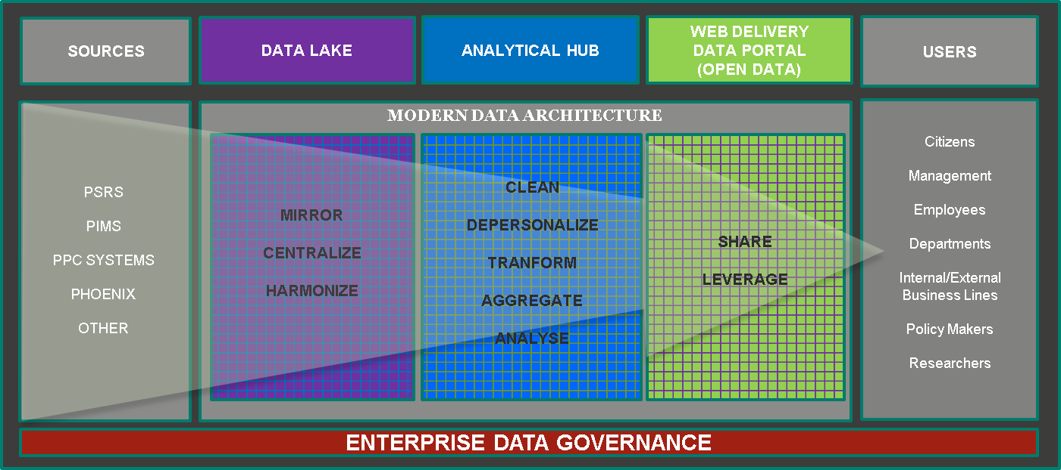
Figure 2: Data Infrastructure Concept
The sources are PSRS, PIMS, PPC Systems, Phoenix and other.
The data Lake is a mirror that centralize and harmonize.
The analytical hub cleans, depersonalizes, transforms, aggregates and analyses.
The web delivery data portal (open data) shares and leverages.
Users are citizens, management, employees, departments, internal/external business lines, policy makers and researchers.

4.2.1 Data Lake: The need to address the challenges of data storage, integration, accessibility, reporting and dissemination across PSC databases and systems has caused the need for a new infrastructure solution. The Oversight and Investigations Sector (OIS) has been identified as the sponsor for the creation of a PSC data lake which will increase access to data integrated from various sources. It will be designed to take snapshots/copies of data on a regular basis to address the need for “real-time” data without jeopardizing live systems, as well as ensuring the ability to reproduce the information in a consistent manner. The new infrastructure will also support more complex analysis, a more nimble visualization capacity, and further contribute to an efficient way of releasing high value products such as open datasets.

Strategy Enablers:
      - Collaborate across PSC sectors to plan and implement the data lake
- Engage data and IT experts, along with business owners, across the PSC and maintain commitment to the success of the data lake.
- Consult with business owners at the concept and planning stage to allow for their business needs to be reflected in the design of the data lake.
- Identify resources from across the PSC dedicated to the data lake initiative.
- Develop a communication and change management plan in support of the data lake.

      - Learn from other organizations
- Consult with other federal departments/agencies on similar initiatives.
- Secure leading edge expertise to guide the planning and implementation of the data lake.

    - Implement Best Practices in Data Management: The implementation of exemplary practices in data management disciplines will contribute to the data lake, and will be done in anticipation of the roll-out of the new infrastructure as well as concurrent with its roll-out. The inter-related practices we will be focusing on are: Metadata Management, Reference and Master Data, and Document and Content Management. As the organization matures, other data management disciplines may be added to the scope of the project.

Metadata Management: Metadata summarizes basic information about data; for instance, author, date created, date modified and file size are examples of very basic document metadata. Metadata helps to organize, find and understand the data. Metadata management ensures that valuable information held in metadata can be integrated, accessed, and analyzed for more effective use across the organization. Metadata management will touch every area of the PSC as we move forward with a new infrastructure and enhanced data integration. Standards for metadata at the PSC need to be established in partnership with business owners in order to enable a number of automated processes that will optimize the use of large volumes of data assets.

Reference and Master Data: Reference data refers to concepts that impact business processes. Master Data is key business information that supports the transactions and is commonly referred to as places (locations, geography, sites), parties (persons, employees) and things (products, items, material). Data entered in different applications (PSRS, PIMS, etc.) may not be accurate or complete enough to fit all purposes due to its focus on the application specific situation and a lack of shared reference tables. At the PSC, for example, this results in a department being identified in different ways in the different operational systems currently in use. The PSC is in need of more robust Reference and Master Data practices, which are key to consolidating information from various sources.

Document & Content Management: Document and Content Management refers to the system in place to organize, store, manage and track data and information. Document and Content Management processes must be reviewed with the intention to identify best practices and standards for the PSC – including how data assets are shared and made available throughout their lifecycles.

Strategy Enablers:
      - Establish organizational norms regarding the capture and use of metadata
- Communicate importance and benefits of access to robust metadata.
- Implement guidelines on Metadata Conventions.

      - Update Reference and Master Data by reviewing common data tables
- Start with Classification, Regions, and Departments.
- Identify other existing Master Data used in operational systems.
- Collaborate across sectors on the development of a business data dictionary/glossary for the Data Lake.

      - Create a PSC corporate data asset inventory
- Identify critical data assets across the PSC required to report on PSC mandate and commitments, such as the Departmental Results Framework.
- Obtain consensus on data that need to be preserved as we plan for the next infrastructure solution and the replacement or upgrade of systems.

      - Document the lifecycle of PSC corporate data assets
- Document responsibilities across the PSC associated with the full life cycle of corporate data assets, from collection to storage, use, sharing, retention and disposition.
- Determine interdependencies between corporate data assets and their business use.
- Establish retention and disposition standards for the DSAD Analytical Environment.

4.3 Data Users - “Know, Understand, Present, Defend”
The PSC is committed to support data users by leveraging the renewal of its infrastructure to create modern channels and products such as automated reports and open datasets. By adopting a client-centered approach, the PSC will be in a position to better engage with data stakeholders to provide value-added products and services and support learning and capacity building in the areas of data management and analysis where appropriate. The PSC remains committed to building the capability it needs to manage, analyze and fully utilize its current and future data holdings.

Strategy Enablers:
    - Communicate Data Products
- Establish a PSC-wide data catalogue that provides the everyday data user with information on the context, intent, location, format, content and frequency of updates.
- Develop and communicate service standards for data products.

    - Promote Self-Service Culture
- Communicate and provide information on new data products (open datasets, reports, etc.).
- Explore new solutions to better meet user needs, including new visualization tools and data analysis applications.
- Support the Open Government initiative by creating an “open by default” culture at the PSC.
- Engage stakeholders to provide value-added data.

    - Build Capacity
- Develop a PSC–wide baseline survey to help establish level of understanding on data, competencies and data related issues and assist in the establishment of priority areas/planning.
- Develop a series of learning modules to boost awareness and knowledge of data and data management disciplines across the PSC.
- Conduct workshops for PSC data users on how to interpret and apply staffing data, including methodologies and limitations.
- Offer refresher courses to PSC employees on Information Management.
- Analyze data requests received in DSAD to inform future data products and service standards.
- Develop and implement a competency-based human resource management framework for data analysts and data scientists.

Appendix A - Governance Structure for Data Management Strategy

Reporting Structure
1. Open Government Working Group reports to Open Government Secretariat
2. Open Government Secretariat reports to Data & Open Government Champion (VP of Oversight and Investigations Sector)
3. Data & Open Government Champion (VP of Oversight and Investigations Sector) reports to President

1. Data Management Working Group reports to Data Management Office.
2. Data Management Office reports to Data & Open Government Champion (VP of Oversight and Investigations Sector)
3. Data & Open Government Champion (VP of Oversight and Investigations Sector) reports to

President
1. Data & Open Government Advisory Board reports to Joint IM/ITC & IC Committee
2. Joint IM/ITC & IC Committee reports to Executive Management Committee

Membership
1. Executive Management Committee membership includes:
- President
- Data & Open Government Champion

2. Joint IM/ITC & IC Committee includes:
- Information Management/Information Technology Committee
- Integration Committee

3. Information Management/Information Technology Committee includes:
- Data & Open Government Champion
- Information Management Senior Official/CIO

4. Data & Open Government Advisory Board includes:
- Open Government Secretariat
- Data Management Office

Collaboration
- Open Government Secretariat and Data Management Office (if necessary)
- Open Government Working Group and Data Management Working Group (if necessary)

Appendix B - Chief Data Officer and Chief Information Officer: Roles and Responsibilities

Accountabilities & Synergies |  | IMSO / CIO | CDO | Programs
IM Action Plan | Developing and Implementing the PSC IM Action Plan | Primary  - Responsible for PSC’s IM Action Plan. Responsible for developing, planning, implementing and reporting on progress.  - CIO: Active participant in design of IM Action Plan. | Stakeholder  - Contributor to design of IM Action Plan.  - Ensures integration and alignment with Data Strategy. | Stakeholder  - Contributors to design of IM Action Plan.
Data Strategy | Leading and Developing the PSC Data Strategy | Partner  - Ensures integration to PSC vision for Open Data, and with IM Policy.  - Ensures alignment with Data Strategy from an enabling technologies perspective.  - Mainly responsible for IT security and infrastructure related to data. | Primary  - Executive Champion for the Data Strategy Vision, and Implementation Plan.  - Leads organization change management initiatives.  - Authors the Data Strategy and ensures stakeholder engagement (within and outside the PSC).  - Ensures alignment of governance bodies to the PSC Data Strategy.  - Identifies risks related to resource capability for implementation, including people, tools and processes and creates forum for the identification of mitigation strategies.  - Responsible for overall quality, interpretation and use of data in support of policy development, program improvement and reporting. | Stakeholder  - Provide input to the Vision.
 | Implementing and Communicating Progress on Data Strategy | Partner  - Accountable for the completion of IM/IT data related activities stemming from the Data Strategy. | Primary  - Responsible for the creation of a project plan, and the management of the rollout of the Data Strategy across the PSC.  - Monitors and communicates progress on the implementation of Data Strategy. | Partner  - Accountable for the completion of data-related activities stemming from the Data Strategy.

Appendix C: Data Management Maturity Model (DMMM)

The DMMM will help in identifying gaps, opportunities and risks relating to PSC’s ability to provide high-quality, authoritative data on staffing in the public service. The DMMM will also act as a tool to develop a list of activities that must be undertaken to address any imminent risks to the organization. This approach will ensure for realignment in the short term and allow for quick-wins.
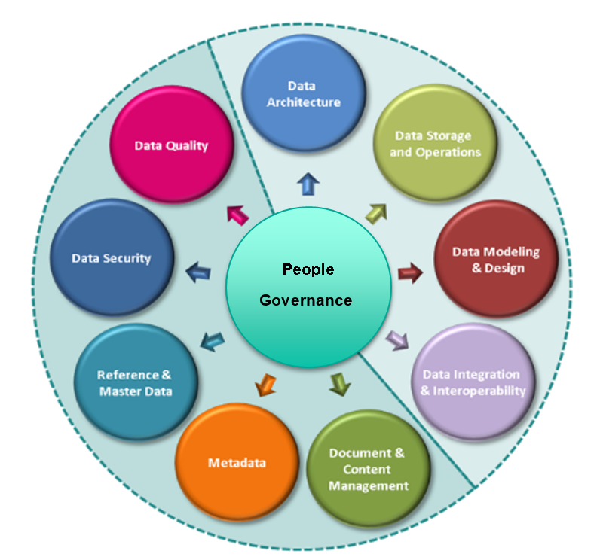
Figure 3: Data Management Disciplines Adapted from Carnegie Mellon University –
Software Engineering Institute (SEI)
Governance and People are the central elements of the model. The other elements of the model are Data Architecture, Data Storage and Operations, Data Modeling and Design, Data Integration and Interoperability, Document Content Management, Metadata, Reference and Master data, Data Security and Data Quality.

Focus Area | Focus of Assessment Inquiry and Measurement
Data Quality | Accuracy, completeness, relevance, timeliness
Data Security | Privacy, access, security, roles, Privacy Impact Assessments, User Consent/Disclosure
Reference and Master Data | Common identifiers (e.g., PRI, DOB, Name, etc.), full applicant profile, “official” list of departments, etc.
Metadata | Tags used for retention, disposition; tags used to describe content and format, attributes to help understand data
Document & Content Management | Data Inventory, Asset lifecycle planning, reports and data used internally and externally, client-centred needs
Data Integration & Interoperability | Usefulness and purpose of data, ensuring data can be used across many systems for multiple user needs
Data Modeling & Design | Establishing standards and “step-by-step” procedures; systematic creation and iteration of building blocks used in queries and reports
Data Storage and Operations | Data Lake, Analytical Hub, Open Government Portal, etc. (technical infrastructure to support storage, staging, analysis, self-service, innovation), client-facing (needs-based) requirements
Data Architecture | Data mapping, understanding flow of data

Appendix D: Acronyms
Acronym | Definition
CDO | Chief Data Officer
CIO | Chief Information Officer
DOB | Date Of Birth
DG | Director General
DMMM | Data Management Maturity Model
DSAD | Data Services and Analysis Directorate
EEDB | Employment Equity Databank
GoC | Government of Canada
IC | Integration Committee
IM | Information Management
IM/ITC | Information Management/Information Technology Committee
IMSO | Information Management Senior Officer
IT | Information Technology
JAIS | Job-Based Analytical System
MOU | Memorandum of Understanding
ODM | Office of Data Management
OIS | Oversight and Investigations Sector
PIMS | Priority Information Management System
PPC | Personnel Psychology Centre
PRI | Personal Record Identifier
PSC | Public Service Commission of Canada
PSRS | Public Service Recruitment System
SOS | Survey Of Staffing
TSRR | Test Scoring and Results Reporting System
VP | Vice-President

https://www.techopedia.com/definition/30194/data-management-strategy
Presentation to joint Integration Committee and IM/IT Committee GCDOCS# 1292516
Redman, Thomas C. (30 December 2013). Data Driven: Profiting from Your Most Important Business Asset. Harvard Business Press. ISBN 978-1-4221-6364-1.
The data risk assessments will be based on the Carnegie Mellon University – Software Engineering Institute Data Management Maturity Model presented in Appendix B.

