Gender-Based Analysis plus (GBA+) Action Plan 2019-21

May 2019
GBA+ Responsibility Centre / Results and Delivery division
GCDocs # 7698005

April 2019
GCDocs # 7698005

Contents

1. Context 3
1.1. What is Gender-Based Analysis plus (GBA+)? 3
1.2. Government direction 4
2. Implementing GBA+ at the Public Service Commission 4
2.1. PSC GBA+ Statement of Intent 4
2.2. How is GBA+ connected to diversity and inclusion at the PSC? 4
2.3. PSC foundations in implementing GBA+ 5
GBA+ Integration Framework 5
GBA+ Responsibility Centre 5
2.4. Planned approach to implement the GBA+ Action Plan 6
Expected outcomes 6
3. GBA+ Action Plan 8
3.1. Governance and Capacity 8
3.2. Awareness and Training 9
3.3. Integration and Impact 10
3.4. Data and Research 12
3.5. Monitoring and Reporting 13
3.6. List of acronyms mentioned in the Action Plan 14

1. Context

1.1. What is Gender-Based Analysis plus (GBA+)?
We all have multiple identity factors that make us who we are, and shape how we experience the world around us.
Gender-Based Analysis plus (GBA+) is a whole-of-government approach that aims to ensure that the potential impacts of government decisions on diverse groups of the population (e.g. based on their gender, ethnicity, geographic area, mental or physical disability, etc.) are considered and addressed as systematically as possible in the development and implementation of policies, programs and services (including internal services).
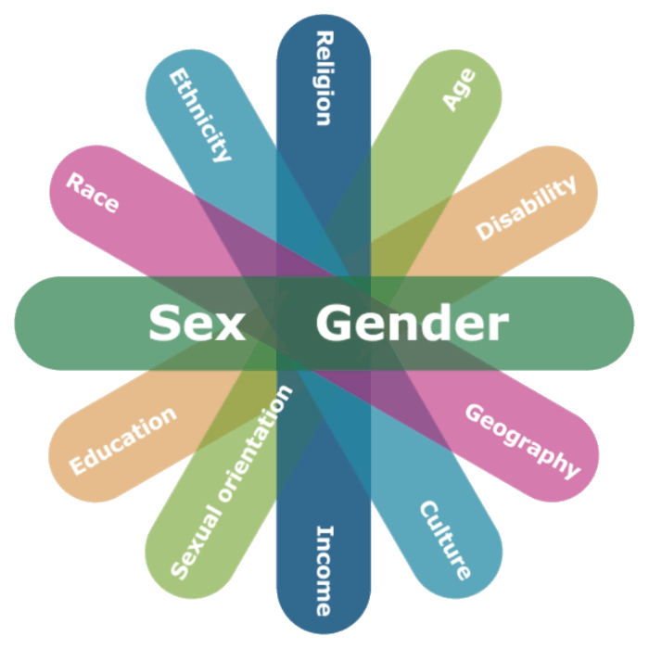
Source: Department for Women and Gender Equality
We can think of GBA+ as an equity-based assessment of our activities and business processes, with a special lens on gender and diversity.
As a « lens » for how we approach our work, GBA+ invites us to:
- challenge our assumptions and unconscious bias;
- systematically ask ourselves the right questions, and ensure that the answers are informed by disaggregated data (when possible and appropriate);
- consider how key demographic and identity factors, as well as their intersections may impact the distribution of opportunities or disadvantages in the population (e.g. regarding hiring and appointments in the federal public service); and
- identify mitigation strategies, whenever possible.
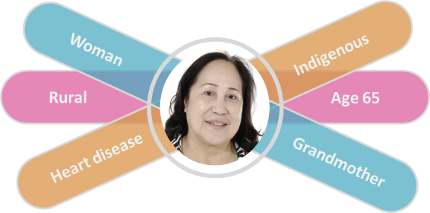
Source: Department for Women and Gender Equality
What is the difference between sex and gender? Sex refers to the biological and physiological characteristics that define men, women and intersex persons. Gender refers to the socially and culturally constructed characteristics of men and women (e.g. norms and roles).

1.2. Government direction
In an effort to eliminate systemic barriers and support equality of outcomes for all Canadians, the Government of Canada has committed to using GBA+ in the development of policies, programs and legislation to mitigate potentially negative impacts on diverse groups of Canadians. There has been an increase momentum over the recent years in government direction to formally integrate GBA+ in departmental work.
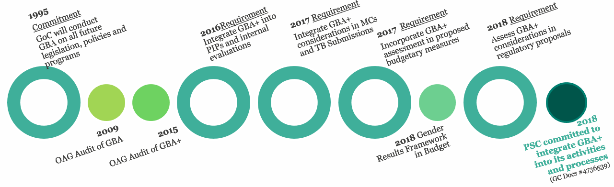

2. Implementing GBA+ at the Public Service Commission

2.1. PSC GBA+ Statement of Intent
The Public Service Commission of Canada (PSC) is committed to meaningfully integrate Gender-Based Analysis plus (GBA+) into its policies, programs and services in support of its efforts to promote and safeguard a merit-based, representative and non-partisan public service that delivers results for all Canadians. The PSC will also use GBA+ to work towards reducing systemic barriers in areas under its responsibility, and to support equality results for Canadians.

2.2. How is GBA+ connected to diversity and inclusion at the PSC?
Diversity & Inclusion (D&I) is a whole-of-organization effort to foster a federal public service that is inclusive and representative of the Canadian population. Within the PSC, D&I structures and activities span across areas such as strategic policy directions, central recruitment programs delivery, and internal human resources.
Gender-Based Analysis plus (GBA+) is an analytical lens that supports D&I by promoting thoroughness in ensuring that gender and other intersecting factors are systematically and meaningfully considered to identify and mitigate (when possible) the potential impacts of our policies, programs and services for diverse groups of Canadians and PSC employees.

2.3. PSC foundations in implementing GBA+
In 2018, the PSC committed in its 2018-19 Departmental Plan to integrate GBA+ into its key activities and processes.

GBA+ Integration Framework
In March 2018, PSC’s Executive Management Committee approved the GBA+ Integration Framework (GC Docs #4736539), which includes five components (see figure). For the first full year of implementing GBA+, the PSC chose to focus its efforts on the Integration & Impact component of the Framework, while also advancing work on the other dimensions. Applying GBA+ in several key initiatives allows to experiment various approaches and identify the most fruitful strategies to meaningfully integrate GBA+ considerations into PSC activities and decision-making processes.
This Action Plan identifies a set of initiatives that will allow the PSC to deliver on the set of measures identified in its GBA+ Integration Framework, for all five components.

GBA+ Responsibility Centre
In August 2018, the PSC established a GBA+ Responsibility Centre (0.75 FTE) as an office of first responsibility for supporting and habilitating the integration of GBA+ across the organization. The location of the GBA+ Responsibility Centre within PSC’s Results and Delivery division (Corporate Affairs Sector) supports a horizontal and results-oriented approach to integrating GBA+ into PSC activities and decision-making processes.
The role of PSC’s GBA+ Responsibility Centre is to habilitate, drive and monitor the implementation of each component of the GBA+ framework, which includes to support the sectors in integrating GBA+ into their work in a timely and meaningful way, by:

In fulfilling these roles, PSC’s GBA+ Responsibility Centre will focus on an approach that is:
- Collaborative;
- Meaningful;
- Evidence-based;
- Built on lessons learned and best practices;
- Sustainable; and
- Results-oriented.

2.4. Planned approach to implement the GBA+ Action Plan
This GBA+ Action Plan (2019-21) outlines key goals and planned initiatives for implementing its GBA+ Integration Framework.
The PSC is well-positioned to undertake this work given:
- its mandate on employment equity and a representative public service;
- the expertise of its Personnel Psychology Centre in fair and accessible assessment practices;
- its data-rich environment and capacity;
- its GBA+ Centre of Responsibility;
- its expected results which include a public service that reflects Canada’s diversity; and
- the support of its senior management for diversity, inclusion and innovation.
During the 2019-20 fiscal year, 0.75 of a full-time employee will be dedicated to GBA+ implementation across the PSC. Additional resources from the Results and Delivery division may periodically be engaged in supporting these efforts. PSC staff across sectors will also be involved in integrating GBA+ considerations in their work, as relevant.
Existing senior management committees will monitor progress in GBA+ implementation. The PSC will report internally and externally on the implementation of the GBA+ activities and initiatives from the Action Plan, and will track how GBA+ considerations have concretely informed the development and implementation of key PSC policies, programs and services.

Expected outcomes
The ultimate outcome intended for the implementation of GBA+ is for all key PSC programs, policies and services to be informed by an evidence-based assessment of their direct and indirect benefits or disadvantages for diverse groups of Canadians (including the consideration of the intersections of multiple demographic and identity factors).
Intermediate outcomes in progressing towards this goal have been identified for each component of PSC’s GBA+ Integration Framework:

3. GBA+ Action Plan
PSC’s GBA+ Action Plan is structured along the same key components as the GBA+ Integration Framework adopted by PSC senior management, and covers the measures that were outlined in that Framework.

3.1. Governance and Capacity
In 2018, the PSC made a clear commitment to integrate GBA+ across its key activities and processes, and established a GBA+ Responsibility Centre (RC) to support and monitor the implementation of GBA+ practices across the organization. A GBA+ Champion at the vice-president level also provides senior management leadership in applying this lens in decision-making processes. Additional activities that will support GBA+ governance and capacity at the PSC are outlined below.
Table 1. Governance and Capacity
Goal | Supporting initiatives | Targeted completion | Accountability
Develop a cross-sectoral network of GBA+ ambassadors to enhance GBA+ capacities and integration on an ongoing basis | As part of a staged approach to the establishment of an internal advisory capacity, develop a network of ambassadors from across PSC sectors to contribute to the consistent integration of GBA+ into PSC activities and processes. | December  2019 | OPI: GBA+ RC  OCI: GBA+ Champion
Develop a cross-sectoral network of GBA+ ambassadors to enhance GBA+ capacities and integration on an ongoing basis | The network could be formalized into a community of practice (or other form of advisory network) at a later stage, once sufficient capacity and expertise in applying GBA+ has been developed (e.g. through awareness and training activities). | September 2020 | OPI: GBA+ RC
Build and sustain external relationships to inform GBA+  implementation at the PSC | Participate in the GBA+ Interdepartmental Network led by the Department for Women and Gender Equality;  Build and sustain relationships with other federal organizations to share information and best practices, and partner as appropriate. | Ongoing | OPI: GBA+ RC

3.2. Awareness and Training
The implementation of GBA+ at the PSC is intended to be carried out by various internal stakeholders across all sectors. To build the capacity and comfort of employees in integrating GBA+ considerations in their activities and decision-making, the PSC has engaged in developing and promoting various resources, tools and learning opportunities. For example, the foundational GBA+ online course is now mandatory for all PSC employees, and the GBA+ Responsibility Centre has developed a set of internal resources to introduce GBA+ in the context of PSC activities. The awareness and training initiatives outlined below are expected to further enhance the development of GBA+ capacity across PSC sectors.
Table 2. Awareness and Training
Goal | Supporting initiatives | Targeted completion | Accountability
Build staff awareness of PSC’s commitment and progress in integrating GBA+ into its activities | Develop communications activities to raise awareness of the PSC’s responsibilities in the area of GBA+ including:  - Disseminating information regarding PSC’s commitment and progress in implementing GBA+ across its activities;  - Promoting PSC activities and events (e.g. potential Open House) that contribute to increase the PSC staff’s knowledge of GBA+ requirements and best practices. | September 2018, and ongoing | OPI: GBA+ RC  OCI: CPAD and  GBA+ Champion
Habilitate PSC employees to effectively integrate GBA+ into their work by providing adequate tools and resources | Promote and leverage existing tools and training opportunities relevant to GBA+ (including, but not limited to, the foundational online course offered by the Department for Women and Gender Equality).  Develop and disseminate complementary PSC-specific tools and resources on an as needed basis. | November 2018, and ongoing | OPI: GBA+ RC

3.3. Integration and Impact
In alignment with PSC’s results-oriented approach to GBA+ implementation, the GBA+ Responsibility Centre has been prioritizing opportunities to support a meaningful integration of GBA+ considerations in key initiatives and internal mechanisms. Leadership and guidance will be provided to ensure that new and existing PSC activities and initiatives are sensitive to the different impacts that decisions can have on diverse groups of women, men and non-binary persons.
Table 3. Integration and Impact
Goal | Supporting initiatives | Targeted completion | Accountability
Meaningfully integrate systematic GBA+ considerations across various stages of PSC policies, programs and services | Throughout the first year of GBA+ implementation, pilot the integration of GBA+ at various stages of key PSC initiatives and innovations, such as:  - the development of a major targeted recruitment initiative;  - the review of a regulation;  - the modernization of the government recruitment platform;  - the design and implementation of the new service delivery model for the National Recruitment Directorate; and  - the development of policy guidance documents for government-wide distribution.  Involvement in these initiatives will include:  - advising and supporting sectors on incorporating GBA+ and developing options to mitigate potential impacts when identified; and  - playing a challenge function for key deliverables such as briefing notes and Treasury Board Submissions. | August 2018, and ongoing | OPI: GBA+ RC  OCI: PCS, SBDS, OIS,  CAS
Meaningfully integrate systematic GBA+ considerations across various stages of PSC policies, programs and services | Pilot the integration of GBA+ into existing PSC activities and processes (e.g. through a challenge function), such as:  - certain products and services developed by the Personnel Psychology Centre ; and  - the preparation of PSC’s annual report. | March 2019, and ongoing | OPI: GBA+ RC  OCI: PCS, SBDS, OIS,  CAS
Meaningfully integrate systematic GBA+ considerations across various stages of PSC policies, programs and services | Lessons learned and feedback gathered from the sectors will feed into the development of more formal mechanisms to systematically integrate GBA+ considerations at various stages of PSC policies, programs and services. Approval will be sought through PSC’s existing governance structure. | March 2020 | OPI: GBA+ RC  OCI: PCS, SBDS, OIS,  CAS
Consider integrating GBA+ into internal briefing material | Develop a proposal for integrating a “Gender and Diversity considerations” section in existing briefing notes templates, to support the systematic consideration of these factors by programs and internal services in preparation of presentations to senior management for information, discussion and/or decision. | September 2019 | OPI: GBA+ RC  OCI: CS
Integrate GBA+ considerations into internal evaluations | Integrate gender and diversity considerations in the planning, examination and/or reporting processes for internal evaluations, in accordance with government-wide requirements. | March 2020 | OPI: IAED  OCI: GBA+ RC
Integrate GBA+ considerations in audits of the staffing system | Integrate GBA+ considerations in the planning, conduct and reporting process for risk-based organizational audits, as appropriate. | September 2019 | OPI: AD  OCI: GBA+ RC
Integrate GBA+ to communication material | Integrate GBA+ considerations to the production and review process for PSC communication material. | December 2019 | OPI: CPAD  OCI: GBA+ RC
Expand GBA+ considerations in key corporate planning tools | Review GBA+ considerations in PSC corporate planning documents (e.g. Performance Information Profiles) to reflect lessons learned in piloting the integration of GBA+ in key PSC activities. | March 2020 | OPI: FAD (RDD)  OCI: GBA+ RC, PCS, SBDS, OIS, CAS

3.4. Data and Research
As an analytical approach, GBA+ is most effective when supported by disaggregated data and relevant research, to help identify the opportunities and inequities that more aggregated data might conceal. The activities below are intended to support the gathering and use of disaggregated data by PSC staff to take into consideration key factors (e.g. gender, disability, age, education and language) in their activities and decision-making.
Table 4. Data and Research
Goal | Supporting initiatives | Targeted completion | Accountability
Generate, monitor and disseminate information that supports GBA+ integration across PSC activities | Systematically integrate gender and potential intersecting considerations into the design, analysis and results dissemination of PSC research, as appropriate (DSAD);  Identify and circulate public information (e.g. Statistics Canada) to PSC staff working on key initiatives to inform their evidence-based considerations of GBA+ factors in their work;  Monitor emerging PSC data and research to support the integration of GBA+ considerations in PSC activities;  Conduct targeted analysis to support sectors in integrating GBA+. | November 2018, and ongoing | OPI: GBA+ RC  OCI: DSAD
Generate, monitor and disseminate information that supports GBA+ integration across PSC activities | Collect and integrate information from PSC’s Personnel Psychology Centre on fair assessment practices in support of GBA+ integration across other PSC activities, as appropriate. | September 2019, and ongoing | OPI: GBA+ RC  OCI: SBDS (PPC)
Strengthen PSC staff’s capacity to use disaggregated data in a manner that supports gender and diversity considerations | Catalogue key PSC data reporting systems to document what disaggregated data (variables) is held and available in each system.  Develop and provide guidance to PSC employees (e.g. through a learning module) on the use of disaggregated data. | March 2020 | OPI: DSAD  OCI: GBA+ RC

3.5. Monitoring and Reporting
The PSC will continue to track and communicate its progress on integrating GBA+ into its activities and decision-making processes. The PSC will also document, on an ongoing basis, the concrete ways in which the integration of GBA+ considerations have resulted in an improved activity or initiative.
Table 5. Monitoring and Reporting
Goal | Supporting initiatives | Targeted completion | Accountability
Track and report on the implementation of the GBA+ activities and initiatives from the Action Plan | Implement internal mechanisms to track progress in implementing planned GBA+ activities and deliverables  Use the governance structure already in place (Resource Management Committee, Executive Management Committee) to monitor the implementation of GBA+ into its activities and business processes  Report externally on PSC’s progress in implementing GBA+ into its activities and business processes. | September 2018 and ongoing | OPI: GBA+ RC  OCI: FAD (RDD)
Monitor GBA+ results | Implement internal strategies to track how GBA+ considerations have effectively informed the development and implementation of key PSC policies, programs and services.  Explore avenues to measure progress against the intended outcomes for GBA+ implementation at the PSC. | November 2018, and ongoing | OPI: GBA+ RC  OCI: FAD (RDD)

3.6. List of acronyms mentioned in the Action Plan
Corporate Affairs Sector (CAS)
Finance and Administration Directorate (FAD)
Results and Delivery division (RDD)
GBA+ Responsibility Centre (GBA+ RC)
Oversight and Investigations Sector (OIS)
Audit Directorate (AD)
Data Services and Analysis Directorate (DSAD)
Policy and Communications Sector (PCS)
Communications and Parliamentary Affairs Directorate (CPAD)
Services and Business Development Sector (SBDS)
Personnel Psychology Centre (PPC)
Corporate Secretariat (CS)
Internal Audit and Evaluation Directorate (IAED)

OPI: Office of Primary Interest - Group(s) with the main responsibility for achieving the deliverable.
OCI: Office of Complementary Interest - Group(s) that, without having the main responsibility for achieving the deliverable, directly support(s) its accomplishment.

