Public Service Commission
Citizenship of applicants and external appointments

Background
The Public Service Employment Act grants preference to Canadian citizens in advertised external appointment processes (“jobs open to the public”). This report looks at how frequently non-citizens and permanent residents apply to and are appointed from jobs advertised to the public. It also explores the employment equity representation of citizen, non-citizen and permanent resident applicants and appointments.

Citizenship of applicants and external hires
- The number of applicants to jobs open to the public has increased in recent years.
- In 2018-2019, there were 368,763 unique applicants to jobs open to the public, an increase from 203,419 in 2015-2016.
  - The share of non-citizen applicants to jobs advertised to the public has also increased over the same period, going from 9.4% (19,013) in 2015-2016 to 14.5% (53,602) in 2018-2019.
- In 2018-2019, there were 20,012 appointments from jobs open to the public (“external hires”), an increase from 10,402 in 2015-2016.
  - In 2018-2019, 2.5% of hires (495 hires) were non-citizens, an increase from 1.5% of hires (159 hires) in 2015-2016.
  - Given the preference for the appointment of qualified Canadian citizens, non-citizens have a lower representation amongst hires than their representation as applicants.

Citizenship and employment equity
- Visible minority applicants are more likely to be non-citizens than their counterparts. Of all applicants, non-citizens account for 22.9% of visible minority applicants, compared to 12.1% of non-visible minority applicants; see Figure 1.
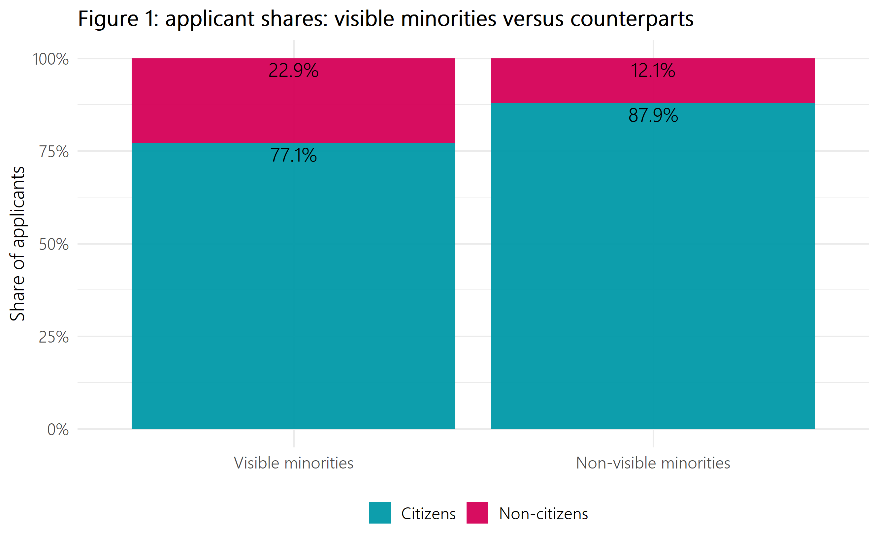
Figure 1: Applicant shares: visible minorities versus counterparts
Table 1: Applicant shares: visible minorities versus counterparts
Employment equity group | Share of citizen applicants | Share of non-citizen applicants
Visible minorities | 77.1% | 22.9%
Non-visible minorities | 87.9% | 12.1%

- Further, non-citizens are less likely to be hired than citizens. As a result, there are fewer non-citizen visible minority applicants that are appointed.
- As seen in Figure 2, visible minorities represent 22.3% of all applicants and 20.7% of hires.
  - When the analysis is restricted to Canadian citizens, visible minorities represent 17.2% of applicants and 19.5% of hires.
  - However, among non-citizens, visible minorities represent 5.1% of all applicants but only 1.2% of all hires.
  - Other factors, such as foreign credentials, may contribute to the drop-off of non-citizens between the application and appointment stage.
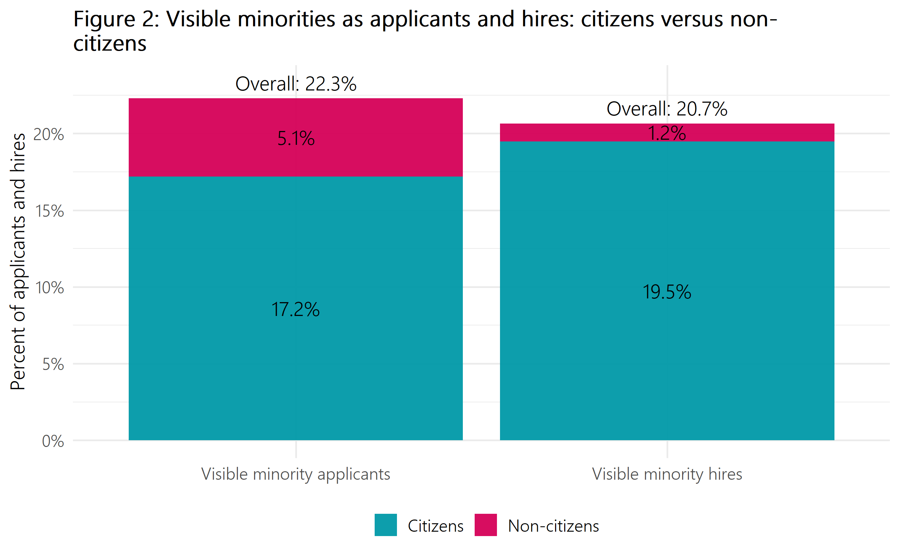
Figure 2: Visible minorities as applicants and hires: citizens versus non-citizens
Table 2: Visible minorities as applicants and hires: citizens versus non-citizens
Representation type | Percent who were citizens | Percent who were non-citizens | Total percent
Visible minority applicants | 17.2% | 5.1% | 22.3%
Visible minority hires | 19.5% | 1.2% | 20.7%

Permanent residents
There are different types of non-citizenship. The following section describes applicant and appointments shares of permanent residents compared to other non-citizens.

Applicants
- Most non-citizen applicants are permanent residents.
  - In 2018-2019, of the 14.5% of applicants who were non-citizens, over two-thirds (37,716 applicants) were permanent residents, while the remaining applicants (15,886 applicants) were not permanent residents.
- Visible minority representation is highest among permanent resident applicants.
  - In 2018-2019, 38.4% of permanent resident applicants to external job advertisements were visible minorities, compared to 20.1% for citizens and 27.5% for other non-citizens.

Appointments
- Most non-citizen hires are permanent residents.
  - In 2018-2019, of the 2.5% of hires who were non-citizens, over three-quarters (387 hires) were permanent residents, while the remaining hires (108 hires) were other non-citizens.
- Visible minority representation is highest among hires who are permanent residents.
  - In 2018-2019, 48.3% of hires who were permanent residents were visible minorities, compared to 20% for citizens and 44.4% for other non-citizens.
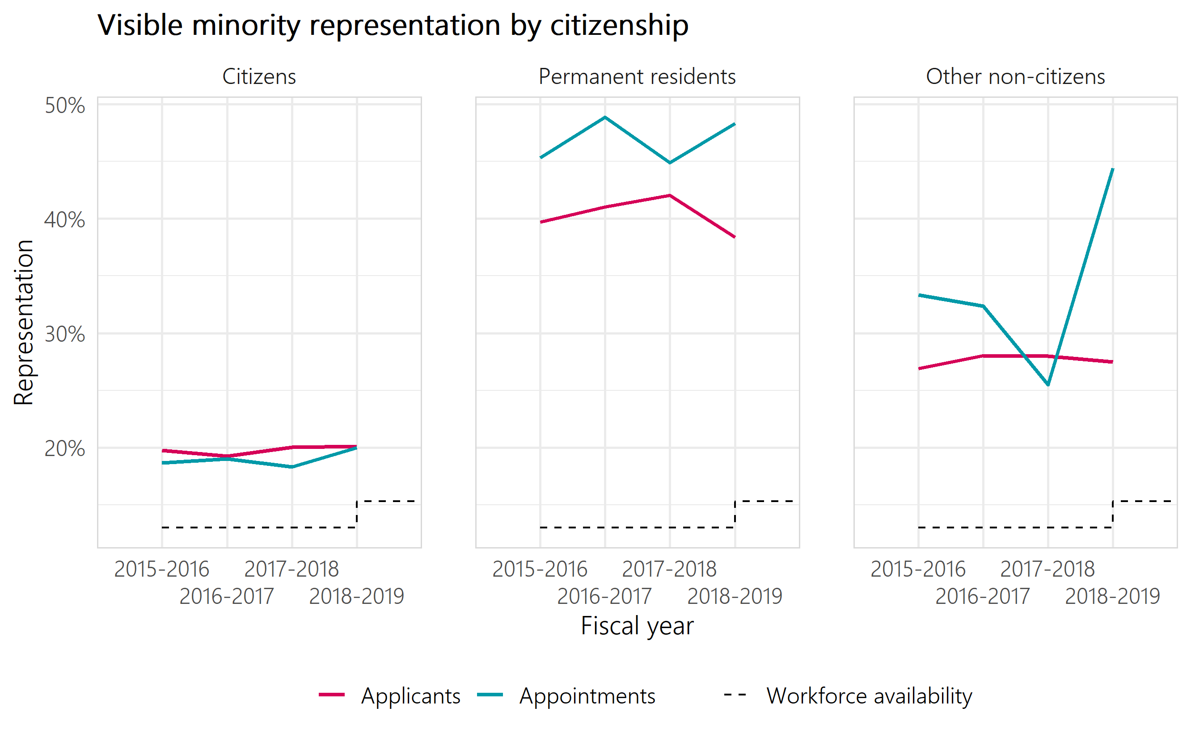
Figure 3: Visible minority representation by citizenship
Table 3: Visible minority representation by citizenship — Canadian citizens
Representation type | 2015-2016 | 2016-2017 | 2017-2018 | 2018-2019
Applicants | 19.8% | 19.2% | 20.0% | 20.1%
Appointments | 18.7% | 19.0% | 18.3% | 20.0%
Table 4: Visible minority representation by citizenship — permanent residents
Representation type | 2015-2016 | 2016-2017 | 2017-2018 | 2018-2019
Applicants | 39.7% | 41.0% | 42.1% | 38.4%
Appointments | 45.3% | 48.9% | 44.9% | 48.3%
Table 5: Visible minority representation by citizenship — other non-citizens
Representation type | 2015-2016 | 2016-2017 | 2017-2018 | 2018-2019
Applicants | 26.9% | 28.0% | 28.0% | 27.5%
Appointments | 33.3% | 32.4% | 25.5% | 44.4%

Methodology
For this analysis, all jobs open to the public for indeterminate and term positions for a duration of three months or greater that closed between April 1, 2015 and March 31, 2019 were evaluated. Similarly, all external hires for indeterminate and term positions for a duration of three months or greater between April 1, 2015 and March 31, 2019 are included.
We assess the citizenship of hires by matching existing public servants to Public Service Resourcing System (PSRS) applications using a deterministic record linkage process. In 2018-2019, the match rate of the record linkage process was 86%.
We assess the employment equity status of applicants by looking at their self-declaration on the PSRS application. Information on women applicants is only available as of April 1, 2016. For hires, we look to their self-identification as collected by the Treasury Board Secretariat in the Employment Equity Data Bank (EEDB). The most recent available data from the EEDB is up to March 31, 2019.
The workforce availability (WFA) based on the 2016 Census was first publicly released in the 2018-2019 Report on Employment Equity. All fiscal years before 2018-2019 in this report are compared to the WFA based on the 2011 Census.
Table 6: Workforce availability (WFA)
Employment equity designated groups | Previous WFA benchmark (2011 Census) | WFA benchmark (2016 Census)
Women | 52.5% | 52.7%
Indigenous peoples | 3.4% | 4.0%
Persons with disabilities | 4.4% | 9.0%
Members of visible minorities | 13.0% | 15.3%
Source: Treasury Board Secretariat, Employment Equity in the Public Service of Canada for Fiscal Year 2018 to 2019

Annex
Note: applicant data for women cannot be reported prior to 2016-2017 due to a change in data capture.
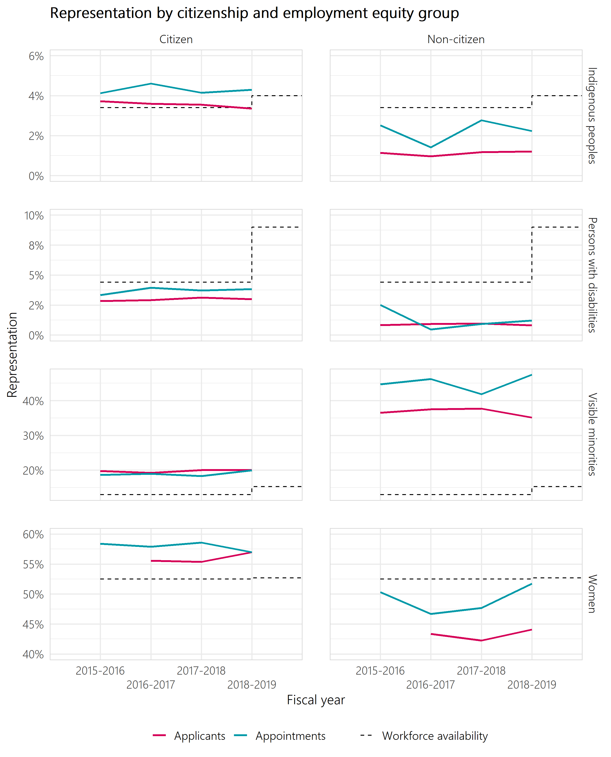
Figure 4: Employment equity representation by citizenship
Table 7: Employment equity representation by citizenship — Canadian citizens
Representation type | 2015-2016 | 2016-2017 | 2017-2018 | 2018-2019
Indigenous peoples applicants | 3.7% | 3.6% | 3.6% | 3.4%
Indigenous peoples appointments | 4.1% | 4.6% | 4.1% | 4.3%
Persons with disabilities applicants | 2.8% | 2.9% | 3.1% | 3.0%
Persons with disabilities appointments | 3.3% | 4.0% | 3.7% | 3.8%
Visible minority applicants | 19.8% | 19.2% | 20.0% | 20.1%
Visible minority appointments | 18.7% | 19.0% | 18.3% | 20.0%
Women applicants |  | 55.6% | 55.4% | 57.0%
Women appointments | 58.4% | 57.9% | 58.6% | 57.0%
Table 8: Employment equity representation by citizenship — non-citizens
Representation type | 2015-2016 | 2016-2017 | 2017-2018 | 2018-2019
Indigenous peoples applicants | 1.1% | 1.0% | 1.2% | 1.2%
Indigenous peoples appointments | 2.5% | 1.4% | 2.8% | 2.2%
Persons with disabilities applicants | 0.8% | 0.9% | 1.0% | 0.8%
Persons with disabilities appointments | 2.5% | 0.4% | 0.9% | 1.2%
Visible minority applicants | 36.5% | 37.5% | 37.7% | 35.1%
Visible minority appointments | 44.7% | 46.2% | 41.8% | 47.5%
Women applicants |  | 43.4% | 42.3% | 44.1%
Women appointments | 50.3% | 46.7% | 47.7% | 51.7%

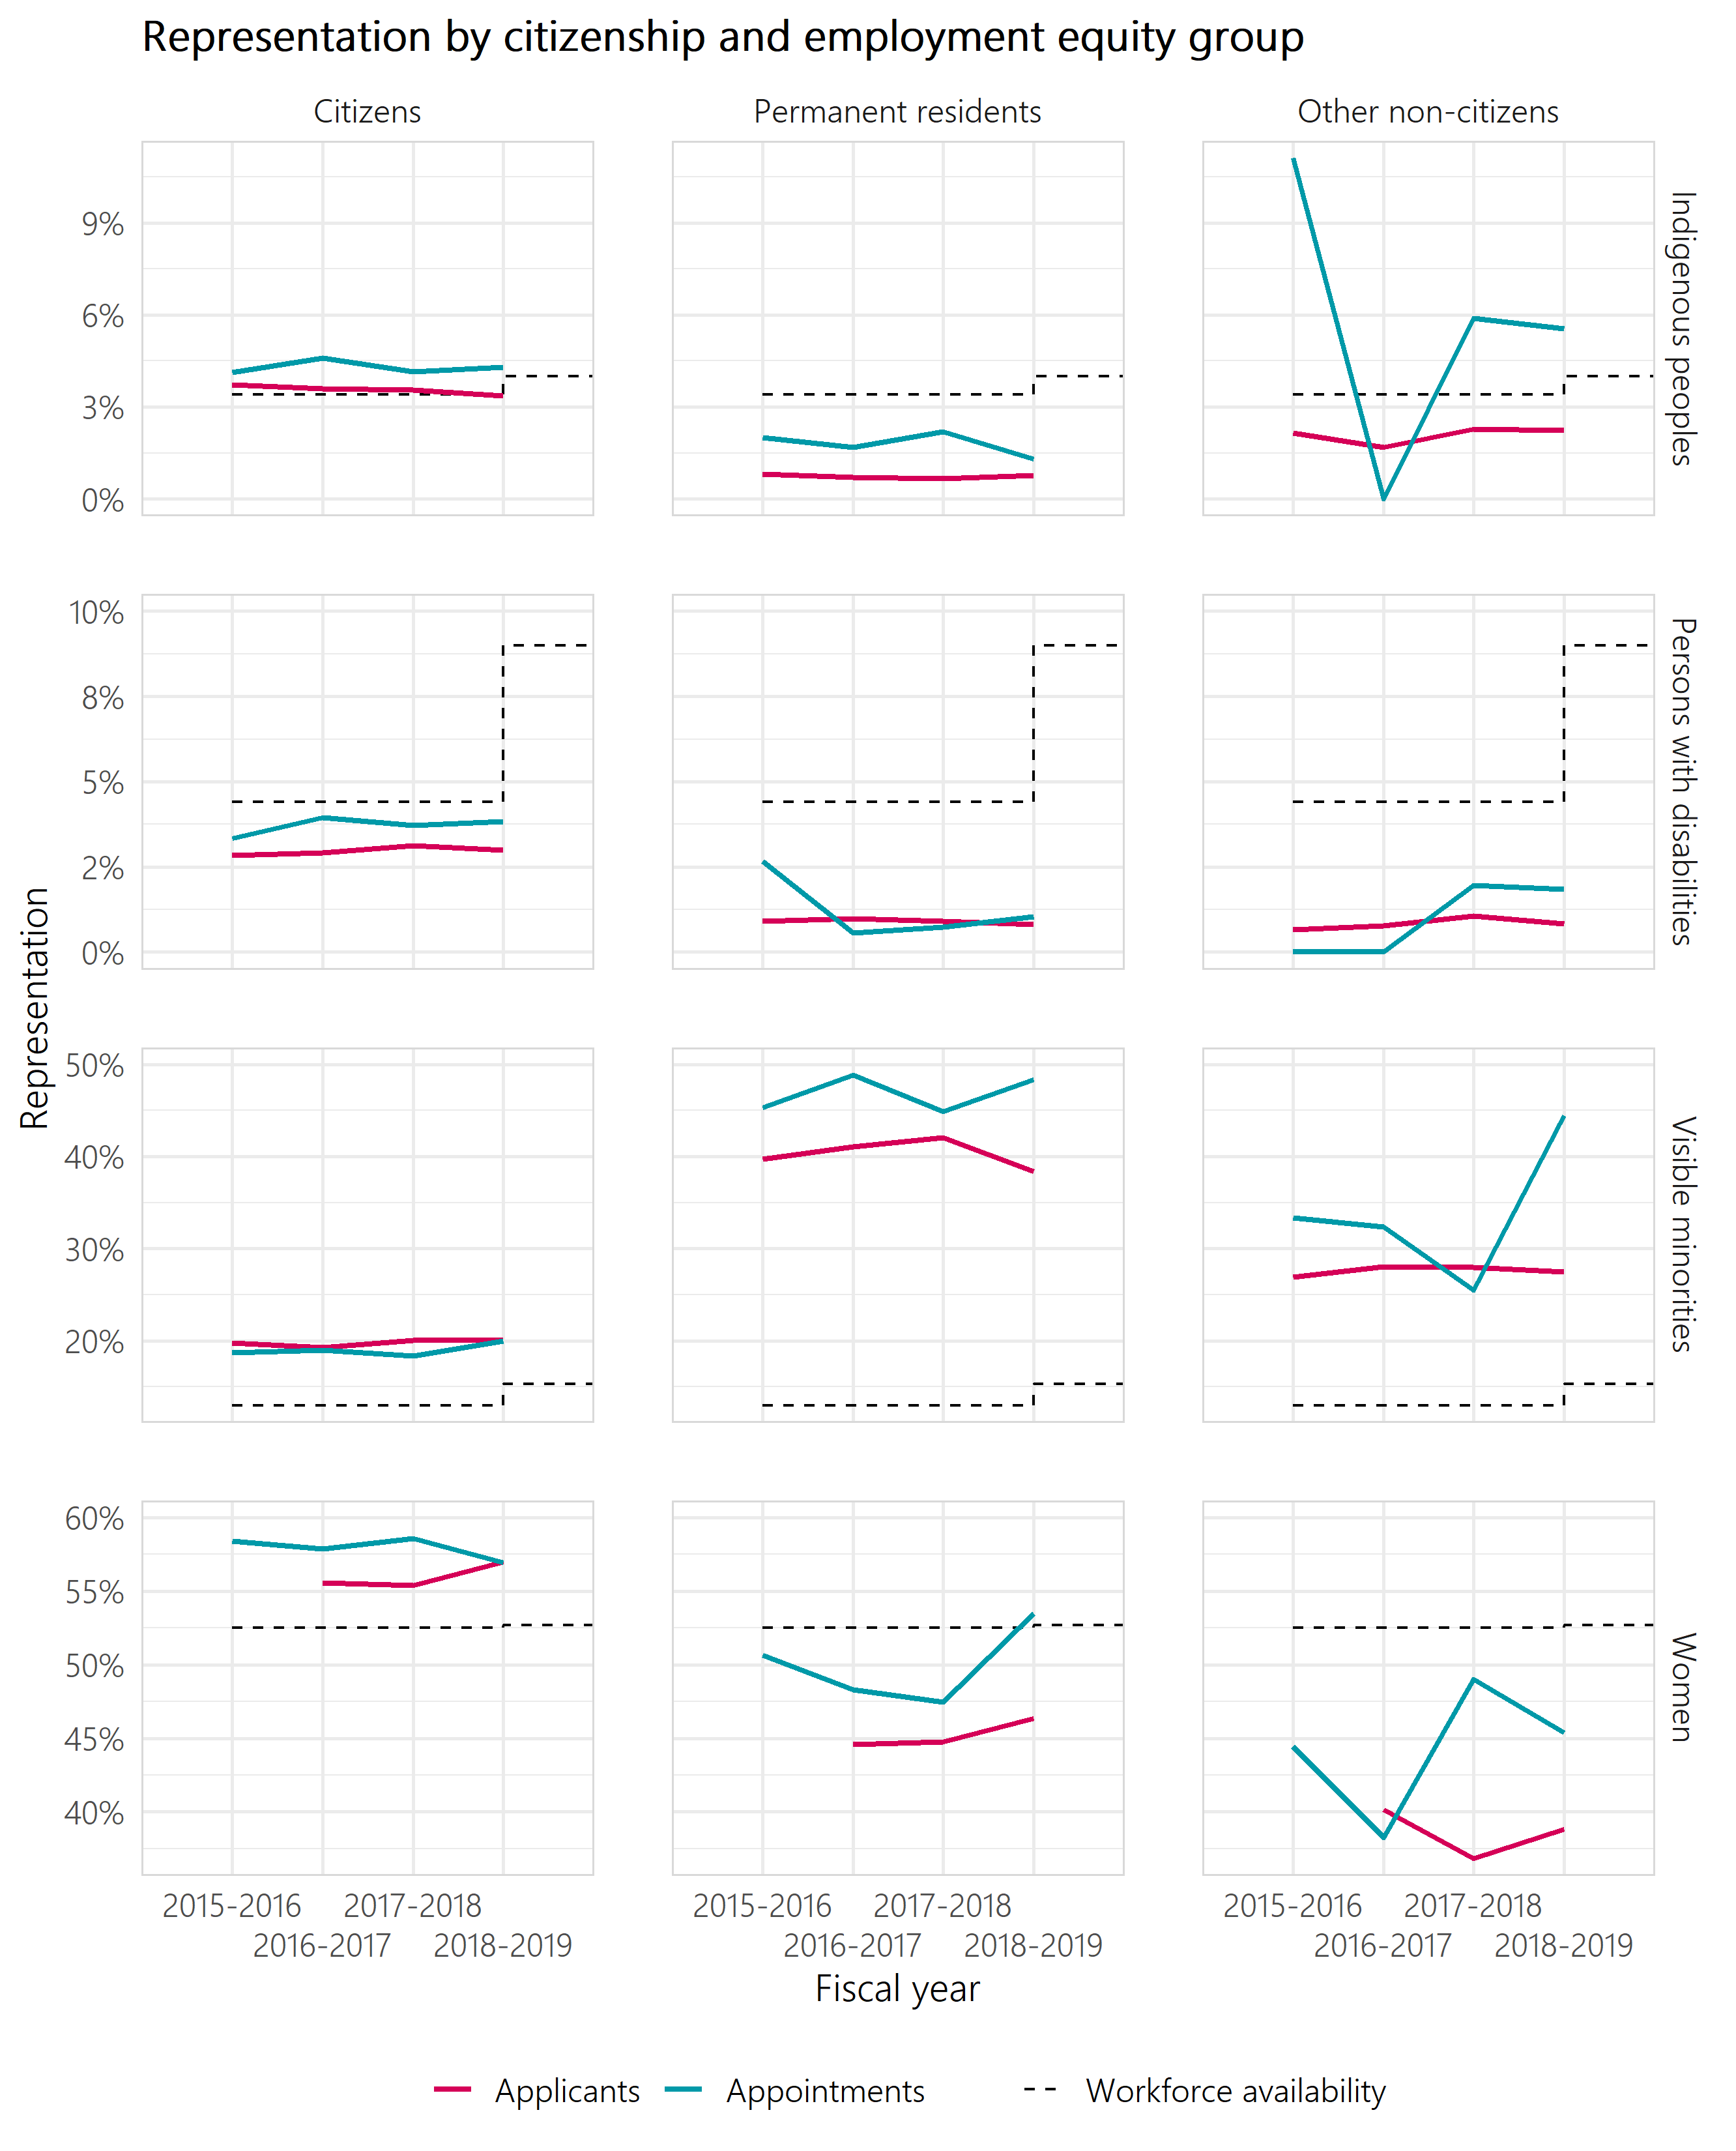
Figure 5: Employment equity representation by citizenship
Table 9: Employment equity representation by citizenship — Canadian citizens
Representation type | 2015-2016 | 2016-2017 | 2017-2018 | 2018-2019
Indigenous peoples applicants | 3.7% | 3.6% | 3.6% | 3.4%
Indigenous peoples appointments | 4.1% | 4.6% | 4.1% | 4.3%
Persons with disabilities applicants | 2.8% | 2.9% | 3.1% | 3.0%
Persons with disabilities appointments | 3.3% | 4.0% | 3.7% | 3.8%
Visible minority applicants | 19.8% | 19.2% | 20.0% | 20.1%
Visible minority appointments | 18.7% | 19.0% | 18.3% | 20.0%
Women applicants |  | 55.6% | 55.4% | 57.0%
Women appointments | 58.4% | 57.9% | 58.6% | 57.0%
Table 10: Employment equity representation by citizenship — permanent residents
Representation type | 2015-2016 | 2016-2017 | 2017-2018 | 2018-2019
Indigenous peoples applicants | 0.8% | 0.7% | 0.7% | 0.8%
Indigenous peoples appointments | 2.0% | 1.7% | 2.2% | 1.3%
Persons with disabilities applicants | 0.9% | 1.0% | 0.9% | 0.8%
Persons with disabilities appointments | 2.7% | 0.6% | 0.7% | 1.0%
Visible minority applicants | 39.7% | 41.0% | 42.1% | 38.4%
Visible minority appointments | 45.3% | 48.9% | 44.9% | 48.3%
Women applicants |  | 44.6% | 44.7% | 46.4%
Women appointments | 50.7% | 48.3% | 47.4% | 53.5%

Table 11: Employment equity representation by citizenship — other non-citizens
Representation type | 2015-2016 | 2016-2017 | 2017-2018 | 2018-2019
Indigenous peoples applicants | 2.2% | 1.7% | 2.3% | 2.2%
Indigenous peoples appointments | 11.1% | 0% | 5.9% | 5.6%
Persons with disabilities applicants | 0.6% | 0.8% | 1.1% | 0.8%
Persons with disabilities appointments | 0 | 0 | 2.0% | 1.9%
Visible minority applicants | 26.9% | 28.0% | 28.0% | 27.5%
Visible minority appointments | 33.3% | 32.4% | 25.5% | 44.4%
Women applicants |  | 40.2% | 36.8% | 38.8%
Women appointments | 44.4% | 38.2% | 49.0% | 45.4%

Trends for other employment equity groups are available in Annex A.
Individuals are given four options when providing information on their citizenship status when applying to federal public service jobs: Canadian Citizen, Permanent Resident, Work Permit, and Other.

