Public service commission

Data Management strategy

Implementation Plan – from Strategy to Practice

Prepared by the Office of Data Management
GCDoc#9980248

Objective
- Outline the implementation plan for the PSC Data Management Strategy
- Provide a companion document to:
- PSC Data Management Strategy: Components and Enablers
- Overview of the Data Management Strategy of the PSC

Background
June 2018: EMC approves the PSC Data Management Strategy*
  - Developed based on industry standards as well as customized elements which best meet PSC needs
  - Meant to be a PSC-wide initiative
Fall 2018: A GC Data Strategy Roadmap is released
Winter 2018:
  - Crosswalk exercise confirms the alignment of both GC and PSC strategies
  - Implementation plan is underway
    - Treat like a PSC-wide project with multiple deliverables
*Please refer to Annex A for the Data Management Strategy drivers and vision.

GC Data Strategy Roadmap
Formally known as the “Report to the Clerk of the Privy Council: A Data Strategy Roadmap for the Federal Public Service”, the GC Data Strategy and its recommendations were submitted to the Clerk and accepted in fall of 2018.
The Roadmap provides 21 recommendations that are structured around four themes:
- Governance
- People and culture
- Data as an asset
- Environment and digital infrastructure

Departmental requirements by September 2019:
- Recommendation 4: Develop data strategies that are relevant, scaled and customized to their needs and aligned with the Data Strategy Roadmap - implementation plan is underway
- Recommendation 5: Require all departments to ensure proper accountabilities, roles and responsibilities with respect to data - CDO function approved – now communicating role and clarifying other data responsibilities

PSC Context
In 2014-2015, the PSC conducted a review of its policy and oversight frameworks. The objective of the review was to strengthen the staffing system’s responsiveness to organizational context and operational risks.
The result of this review, a New Direction in Staffing, was a sensible deregulation of the staffing system which aims to provide hiring managers with the discretion to choose the resourcing strategy that best supports their organizational outcomes.
For hiring managers, exercising greater discretion will entail a transition from supporting a values-based staffing system in a regulated environment to values-based decision making where competing values may be at play.

Why is data important for the PSC?
Although our staffing environment has changed, the desired outcomes of the staffing system remain the same:
- A highly competent and non-partisan public service drawn from across the country, benefitting from diversity, linguistic duality and range of backgrounds and skills;
- Appointment processes designed so as not to discriminate or create systemic barriers;
- Appointment processes conducted in a fair manner and in good faith, free from political influence, fraud, improper conduct, personal favouritism and bias; and
- Timely correction of errors and omissions

Leveraging data to ‘nudge’ the staffing environment
- Based on behavioural economics principles, research points to the value of providing decision makers with tools and information to support better outcomes. In essence, not to coerce or regulate the right behaviours but to “nudge” hiring managers into making the best decision.
- A deregulated environment represents a unique opportunity for the PSC to play a vital role in promoting desired outcomes in the staffing system.
- Therefore, through relevant and innovative research and data that help highlight system-wide issues, the PSC can effectively “nudge” hiring managers toward effective values-based staffing decisions.

To keep in mind as we move forward
It is by optimizing the use of its data that the PSC will be better positioned to develop relevant and innovative products, services and guidance to assist departments in addressing their operational realities.
In planning the implementation of the Data Management Strategy, the Executive Management Committee stressed the importance of the:
- Human aspect behind the Strategy and its impact on employees
- Risk tolerance for an error
- Ethical use of data

The Human Aspect
- The human aspect will be addressed by developing a:
  - Change Management and Communication Plan in the first year of implementation; and
  - PSC Data Literacy Plan to respond to the Data Management Baseline Survey results.
- Leveraging social media to raise awareness of the Data Management Strategy will also be key in changing the organizational culture towards greater knowledge and use of data.
- The corporate Learning Team will be a key player in supporting the learning experience of employees.

Risk tolerance for an error
- The degree of uncertainty that is acceptable to the organization, depending on the nature and the purpose of the data, is not fully understood.
- Light will be shed on this consideration by:
  - Clarifying the roles and responsibilities of various actors with respect to data;
  - Operationalizing the Data Approval and Dissemination Protocol throughout the organization; and
  - Developing tools/guidance to support data quality across all sectors.

Ethical use of data remains a priority
As interest in staffing data increases, a reflection that goes beyond privacy and security issues is required to better define the conditions under which PSC data can and should be used and shared.
Guidelines and templates for Data Sharing Agreements will be developed to capture:
- privacy - protect the privacy of individuals with respect to personal information and the requirements of the Privacy Act (PA) and the Access to Information Act (ATIA);
- consent - what are individuals consenting to when they provide information;
- mandate - of the organization that collects the information versus the mandate of the organization that wishes to obtain and use PSC data; and
- intended use of data - original intent versus emerging possibilities such as research and AI
In addition, we will:
- Create a corporate list of data sharing agreements and confirm alignment with PA and ATIA;
- Review privacy notice statements; and
- Implement mechanisms to mitigate duplication of data holdings, both local and procured.

Where are we now?
Data Management:
- Data governance established
  - Partnership between business owners, data experts and technology stewards
- CDO function approved and Data Management Office in place
Data Infrastructure:
- Feasability analysis of Data Lake underway
  - Start with PIMS
Data Users:
- Getting ready for PSC Data Literacy Plan
  - Baseline survey of PSC data users completed and analysis is underway
    - how data is used at the PSC
    - type of support that would help employees
    - what competencies are needed
- Competency-based framework for data analysts/scientists in progress

Proposed Phases and key deliverables
(See Annex B for priorities and timelines)

Phase 1: Establish the Foundation (2019-2020)
- Clear data roles and responsibilities (i.e.: CDO, Business, Data stewards/curators, Data custodians)
- Enterprise data management maturity assessment - include assessment of risks such as capacity, security and privacy
  - Start with self-assessment using PIMS
- Feasibility assessment for a Data Lake and schedule for infrastructure from SSC
- PSC Data Literacy Plan - in complement to GC learning initiatives
- User centric data access plan – based on results from engagement activities on PSC and Open Government data needs
  - Start with the replacement of Impromptu
- Strengthened data management practices and ethical use of data

Phase 2: Build Momentum (2020-2021)
- Action plans/mitigation strategies developed and steps taken to address data risks and maturity findings
- Data infrastructure in place or under development - Data Lake (or alternative) subject to prioritization process
- Master Data Management Plan
- Data Access and Dissemination Plan - including data analytics and visualization approach/tools
- Delivery of learning modules
- Alignment of PSC Data Management Strategy with GC direction and with data needs of Next Gen HR

Phase 3: Assess Progress and Adjust (2021-2022)
- Measure and assess progress (internal audit planned for 2021)

Next Steps
- Develop Project Charter
- Establish Project Plan
- Report on progress to the data governance

Annex A - PSC Data Management Strategy

Drivers and Vision

PSC drivers for a data strategy
From:
- Inconsistent management of data in siloes
- No strategic oversight of the use of data
- PSC employees do not always have access to the data that they need
- Data not consistently treated as a strategic asset to support decision making
- Some employees may not have the skills or the tools that they need to use data effectively
Trought:
- Robust data governance and stewardship
- Data user-centric philosophy
- Increased availability and interoperability of data
- Increased data analytics and effective use of data
- Capacity building in data literacy and use
To:
Expected outcomes
- Data is managed as a PSC-wide asset in a way that respects privacy, security and IM practices
- More robust data is used to report to Parliament, inform and solve business problems, support evidence-based adjustments to policies, inform improvements in program and service delivery
- PSC has the capacity and the competencies to use data and has access to modern, high performance data analytics
- PSC is a leader in self-service and open data

Vision: the right data, the right way, in the right hands, at the right time

Figure 1: Elements of PSC’s Data Management Strategy
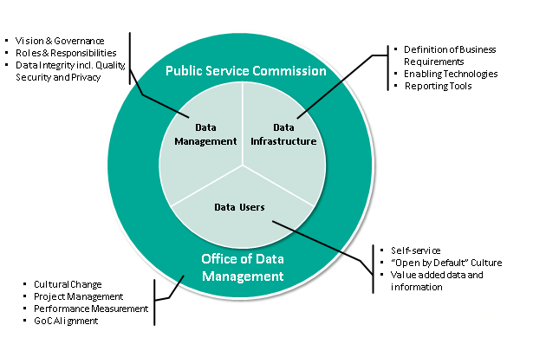
Alternative text:
Sub-elements related to Data Infrastructure are definition of Business Requirements, Enabling Technologies and Reporting Tools.
Sub-elements related to Data Users are Self-service, "Open by Default" Culture and Value added data and information.
Sub-elements related to Data Management are Vision & Governance, Roles & Responsibilities and Data Integrity including Quality, Security and Privacy.
The sub-elements related to the Office of Data Management are the Cultural Change, Project Management, Performance Measurement and GOC Alignment.

Foundational elements of data infrastructure
Figure 2: Data Infrastructure Concept
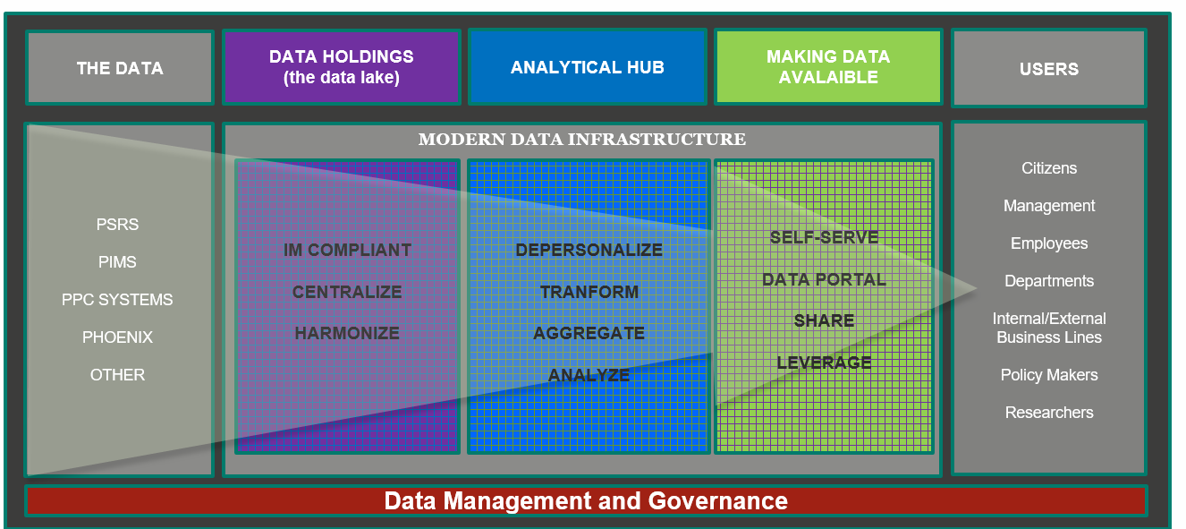
Alternative text:
The data is PSRS, PIMS, PPC Systems, Phoenix and other.
The data holdings (the data lake) are IM compliant, centralize and harmonize.
The analytical hub depersonalizes, transforms, aggregates and analyzes.
Making data available: data is shared and leveraged and is available on a data portal and self-serve.
Users are citizens, management, employees, departments, internal/external business lines, policy makers and researchers.

Annex B - PSC Data Management Strategy Proposed Priorities and Timelines

PHASE 1: ESTABLISH THE FOUNDATION – DATA MANAGEMENT
Actions |  | Activities | Timeline
Clarify data responsibilities | Define CDO and data actors’ R&R including supporting the PSC data sharing protocol |  | April to May 2019
Assess current situation | Assess PSC data risks /self-assessment 1st |  | May to August 2019 and September 2019 to January 2020
Assess current situation | Conduct PSC data management maturity diagnostic / self assessment 1st |  | May to August 2019 and September 2019 to January 2020
Assess current situation | Develop action plans/mitigation strategies |  | January to March 2020
Assess current situation | Review privacy notice statements |  | December 2019 to April 2020
Plan | Develop Results Measurement Framework |  | April to August 2019
Plan | Develop Change Management/ Communications Strategy |  | June to December 2019
Plan | Establish corporate list of data agreements |  | July to September 2019
Plan | Create templates and guidelines for data sharing within and outside the PSC |  | July 2019 to January 2020
Plan | Implement mechanisms to mitigate duplication of data holdings |  | December 2019 to April 2020

PHASE 1: ESTABLISH THE FOUNDATION – DATA INFRASTRUCTURE
Actions | Timeline
Initiate feasibility assessment for Data Lake - PIMS | March to July 2019
Initiate PSC Corporate Data Asset Inventory | July 2019 to April 2020

PHASE 1: ESTABLISH THE FOUNDATION – DATA USERS
Actions |  | Activities |  | Timeline
Assess state of data literacy | Conduct analysis of Baseline Survey results |  | March to April 2019
Assess state of data literacy | Develop PSC Data Literacy Plan |  | April to July 2019
Assess state of data literacy | Develop data literacy material (one module at a time - start with data quality) |  | July 2019 to January 2020
Assess state of data literacy | Deliver learning modules |  | October 2019 to April 2020
Release data of value | Engage to provide value-added data |  | March to September 2019
Release data of value | Update open datasets and release new ones |  | September 2019 to April 2020
Strengthen analytical capacity | Develop and implement a competency-based framework for data analysts/scientists |  | March 2019 to April 2020
Strengthen analytical capacity | Establish sandbox to test and procure advanced analytical and visualization tools |  | March to September 2019

PHASE 2 PRIORITIES: BUILD MOMENTUM – DATA MANAGEMENT
Actions | Activities |  | Timeline
Develop PSC Policy on Data Quality |  |  | April 2020 to January 2021
Continue implementation of action plans/mitigation strategies to address |  | Risks findings | March 2020 to April 2021
 |  | Maturity diagnostic findings | March 2020 to April 2021
Implement Change Management/Communications Strategy activities |  |  | March to October 2020
Assess progress against Results Measurement Framework for DMS |  |  | October 2020 to April 2021

PHASE 2 PRIORITIES: BUILD MOMENTUM – DATA INFRASTRUCTURE
Actions | Timeline
Implement Data Lake environment | July 2020 to April 2021
Establish Master Data Management Plan | April 2020 to January 2021
Develop PSC Policy on Data Security and Privacy | April 2020 to January 2021

PHASE 3 PRIORITIES: ASSESS AND ADJUST – DATA MANAGEMENT
Actions |  | Activities |  | Timeline
Assess PSC data literacy progress | Administer and analyze second survey results |  | April to July 2021
Align PSC Data Strategy with GC direction | Update PSC Data Strategy and align with GC direction and PSC needs |  | July to December 2021

PHASE 3 PRIORITIES: ASSESS AND ADJUST – DATA INFRASTRUCTURE
Actions |  | Activities |  | Timeline
Onboard new data holdings in the Data Lake | Data holding(s) TBD |  | April 2021 to April 2022
Expand data management practices | Establish organizational norms regarding the capture and use of metadata |  | April to October 2021
Expand data management practices | Implement and standardize Reference Tables for Classifications, Regions, Departments |  | April 2021 to January 2022

PHASE 3 PRIORITIES: ASSESS AND ADJUST – DATA USERS
Actions | Timeline
Assess the outcomes of the Strategy | April 2021 to April 2022

